Windows Server & Active Directory Lab — Project Documentation
Oct 13, 2026 · @Ayomide
This is the working documentation for a hands-on Windows Server and Active Directory lab — a single lab.local domain that I build, break, fix, and learn from. It is living documentation: every section is something actually built and verified on the lab, and more is added as the project grows.
Everything runs on one domain controller in the lab.local domain. Chapter 1 stands up a mail server on it with hMailServer and eM Client. Chapter 2 is the Active Directory side — organisational units, groups, a department file server, Group Policy, and a security baseline for workstations.
What's covered so far
- Installing hMailServer, the mail-server engine, and connecting eM Client to it
- When mail won't send: how DNS and a second network adapter break delivery
- Groups and their three scopes — the AGDLP pattern
- A department file server: NTFS vs share permissions
- Mapping drives automatically with Group Policy
- Structured OUs and a security baseline for workstations
- A managed desktop wallpaper — and the UNC path gotcha
Chapter 1 — The mail server (lab.local)
What the mail server does, and why
The result is a working mail server running on the domain controller, with two mailboxes that send email to each other through eM Client. It ties together three things: DNS records, user accounts, and a real desktop application talking to a server over the network.
The lab setup
Item | Value used in this lab
Domain | lab.local
Server (domain controller) | DC01
Server IP | your DC's static IPv4 (Part 1 shows how to find it)
Mail server software | hMailServer (free)
Mail client | eM Client (free)
Mailboxes | john@lab.local, mary@lab.local
One rule worth stating up front: in a real company you never run a mail server on a domain controller. A domain controller should do one job, and mail exposes it to the outside world, which is a security risk. It is done here only because the lab has one server and the point is to learn the moving parts — the production habit is a dedicated mail server.
Part 0 — Set up the two VMs and their network (do this first)
Already have the two VMs talking? If the Windows client can log in to the domain with an account created on the DC, this whole part is done and proven — a domain login only works when both VMs share an isolated network, the client's DNS points at the DC, and they can reach each other. In that case, skip to Part 1. The steps below are for a fresh pair of VMs, or for tracing a login that breaks.
The lab is two virtual machines: the server (DC01, Windows Server) and a client (Windows 11). The two VMs must talk to each other but to nothing else. You achieve that by putting both VMs' network adapters on the same isolated virtual network.
Why an isolated network: with both VMs on their own private network, the lab uses fixed, predictable IP addresses that never clash with anything else, and nothing on it can reach — or be reached from — the real LAN or the internet. That isolation is what makes it safe to experiment freely.
Step 1 — Put both VMs on one isolated network. Use whichever hypervisor you run:
Hypervisor | What to set (on BOTH VMs)
VirtualBox | VM - Settings - Network - Adapter 1 - Attached to: Internal Network, Name: LabNet (identical on both VMs)
VMware Workstation / Player | VM - Settings - Network Adapter - LAN Segment, create/pick LabNet (same segment on both VMs)
Hyper-V | Virtual Switch Manager - New virtual switch - Private - name LabNet; then each VM - Settings - Network Adapter - Virtual switch: LabNet
These modes isolate the two VMs together with no internet, which is exactly what the lab wants.
If the DC needs internet (for example to download hMailServer), the simplest route is to download all the installers before isolating. Otherwise add a second adapter to DC01 set to NAT (VirtualBox/VMware) or an External switch (Hyper-V), do the downloads, then disable it.
Step 2 — Give each VM a static IP by hand. There is no router on this isolated network, so nothing hands out addresses. Set them manually in each VM under Network settings - adapter - IPv4 properties - Use the following IP address:
Machine | IP address | Subnet mask | Preferred DNS | Default gateway
DC01 (server) | 192.168.10.10 | 255.255.255.0 | 192.168.10.10 (itself) | leave blank
CLIENT (Windows 11) | 192.168.10.20 | 255.255.255.0 | 192.168.10.10 (the DC) | leave blank
The single most important line is the client's DNS = the DC's IP. That is how the client finds the domain, the mail server, everything. The gateway is blank because there is nowhere else to route to.
Step 3 — Prove the two VMs can see each other. From the client VM, before anything else:
ping 192.168.10.10
If the DC does not reply, run Set-NetFirewallRule -Name FPS-ICMP4-ERQ-In -Enabled True on DC01 to allow ping, or temporarily turn its firewall off to confirm the network itself works. Nothing else in this guide will work until this ping succeeds.
The three adapter modes — this is where most VM labs go wrong:
- NAT — the VM reaches the internet but is invisible to other VMs. Wrong for this lab.
- Internal / Private — the VMs talk only to each other, isolated. This is what we use.
- Bridged / External — the VM joins the real LAN like a physical PC. Powerful, but then every VM shares one network and the fixed IPs would collide.
Part 1 — Confirm the server's static IP (10 min)
Mail finds the server by its IP address, so that address must never change. A server on DHCP could get a new address overnight and break mail for everyone, so the first job is to check the DC has a fixed (static) address and note what it is.
On DC01, open PowerShell and run:
ipconfig
Look at the Ethernet adapter's IPv4 Address line. That number is your server's IP, and you will type it into the DNS record in Part 2. Write it on the board.
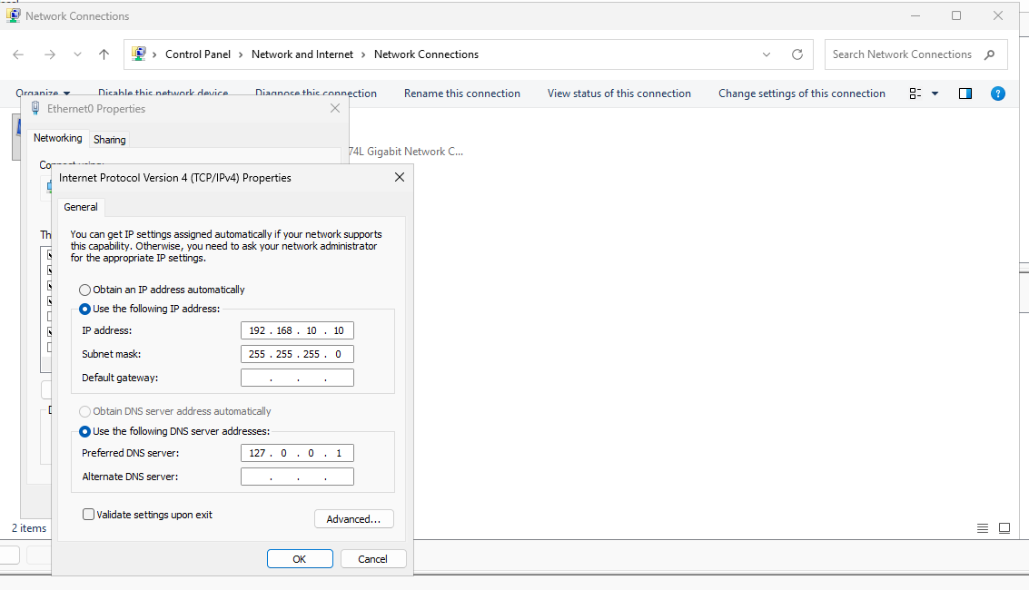
The DC's adapter: a static 192.168.10.10 with DNS pointed at itself (127.0.0.1). A domain controller must have a fixed IP, never DHCP.
Now check it is static, not handed out by DHCP:
Get-NetIPAddress -AddressFamily IPv4 | Where-Object {$_.IPAddress -notlike "169.*" -and $_.IPAddress -ne "127.0.0.1"} | Select IPAddress, PrefixOrigin
- PrefixOrigin = Manual means it is static. Good, carry on.
- PrefixOrigin = Dhcp means you must set it to static first: open Settings - Network - Change adapter options - right-click the adapter - Properties - Internet Protocol Version 4 (TCP/IPv4) - Use the following IP address, and type in the address, subnet mask, gateway, and set the DNS server to the DC's own address. This is a worthwhile lesson in itself.
Note: a 169.254.x.x address means the machine got no address at all — a DHCP problem, not a mail problem.
Part 2 — Create the DNS records on the DC (10 min)
Email is delivered in two DNS lookups: one to find which server handles mail for the domain (the MX record), and one to find where that server is (the A record). Set up both now, before touching the mail software.
On DC01, open DNS Manager and expand Forward Lookup Zones → lab.local.
1. The A record (the server's name)
- Right-click the lab.local zone and choose New Host (A or AAAA).
- Name: mail
- IP address: your DC's static IP from Part 1.
- Click Add Host.
This creates mail.lab.local, pointing at the server.
2. The MX record (where mail for the domain goes)
- Right-click the lab.local zone and choose New Mail Exchanger (MX).
- Leave Host or child domain blank, so the record covers the whole domain (@lab.local).
- Fully qualified domain name of mail server: mail.lab.local
- Mail server priority: 10
- Click OK.
Why two records: the MX record says “mail for lab.local goes to the server called mail.lab.local”; the A record says “mail.lab.local lives at this IP.” Two separate questions, two separate records.
Test before moving on. In PowerShell on the DC:
nslookup -type=mx lab.local
nslookup mail.lab.local
The first should return mail.lab.local, the second should return your server's IP. If either fails, fix it here — the mail software cannot work until DNS does.
The lab.local zone with both records in place: the A record mail → 192.168.10.10 and the MX record pointing to mail.lab.local. These two are what make mail delivery findable.
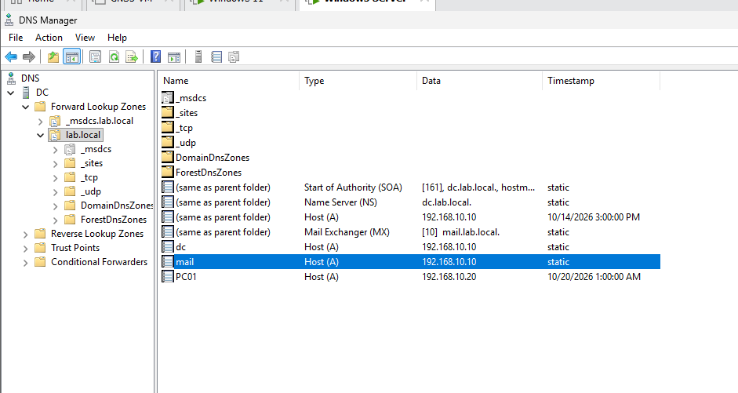

Part 3 — Install hMailServer (10 min)
hMailServer is a free, well-known mail server for Windows. It is the engine that will actually receive and store the email.
- On DC01, download hMailServer from hmailserver.com (the Downloads page).
- Run the installer. Click through until it asks about the database.
- Choose Use built-in database engine (Microsoft SQL Compact). For a lab this needs no setup and keeps everything self-contained.
- It then asks for an hMailServer administrator password. This is the password for the management tool, not for any mailbox. Pick one and write it on the board.
- Finish the install. The hMailServer Administrator console opens.
- Click Connect, choose localhost, and enter the administrator password you just set.
You are now looking at the console where you create the mail domain and the mailboxes.
Why it matters: keep the two passwords separate from the start. The administrator password manages the server; each mailbox has its own, different password that users type into their mail client. Mixing them up is the most common early confusion.
Part 4 — Create the mail domain and mailboxes (10 min)
Now tell hMailServer which domain it handles and create two people who can email each other.
1. Add the domain
- In the hMailServer Administrator, click Domains in the left tree, then Add...
- In Domain, type lab.local.
- Click Save.
2. Add two mailboxes
- Expand lab.local → Accounts, then click Add...
- Address: john (hMailServer fills in @lab.local automatically). Set a Password. Click Save.
- Click Add... again and make mary@lab.local the same way, with its own password.
Note both mailbox passwords — they get typed into eM Client in Part 6.
3. Let the lab network send and receive
hMailServer only accepts connections from IP ranges you allow. The default install already allows the local machine, but add the lab subnet so the client PCs can connect.
- Go to Settings - Advanced - IP Ranges.
- Check there is a range covering your lab network (for example 192.168.10.0 with mask 255.255.255.0). If not, click Add... and create one.
- In that range, make sure these are ticked: Allow connections: SMTP, POP3, IMAP, and under Allow deliveries, both Local to local and external to local.
- Keep Require SMTP authentication ticked for the local range. It is good practice, and eM Client handles it fine.
- Click Save.

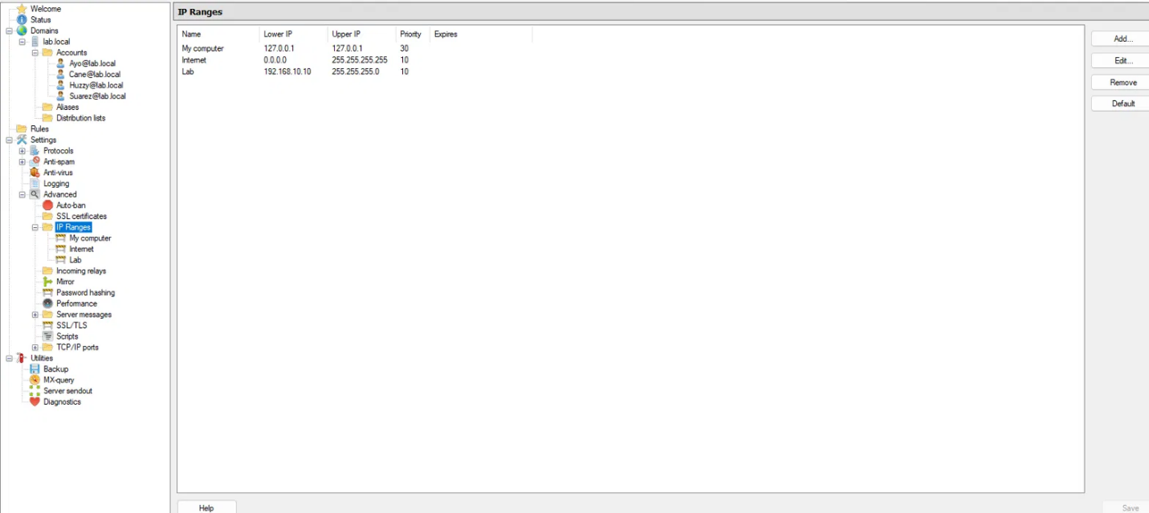

hMailServer's IP Ranges: the Lab range (192.168.10.0/24) is what lets the client PCs connect. Without it, mail from a client is refused even though the server is running.
Note: this IP-range screen is hMailServer's own firewall — it decides who is even allowed to talk to the mail server. If mail later fails to send, it is one of the first places to look.
Part 5 — Open the firewall ports on the server (5 min)
The client PCs cannot reach the mail server until Windows Firewall on DC01 lets these ports through. In an elevated PowerShell on DC01:
New-NetFirewallRule -DisplayName "Mail SMTP" -Direction Inbound -Protocol TCP -LocalPort 25 -Action Allow
New-NetFirewallRule -DisplayName "Mail IMAP" -Direction Inbound -Protocol TCP -LocalPort 143 -Action Allow
New-NetFirewallRule -DisplayName "Mail POP3" -Direction Inbound -Protocol TCP -LocalPort 110 -Action Allow
The ports, and what each one does (worth putting on the board):
Port | Protocol | Job
25 | SMTP | Sending mail, and server-to-server delivery
143 | IMAP | Reading mail, leaving it on the server (what we use)
110 | POP3 | Reading mail by downloading it off the server
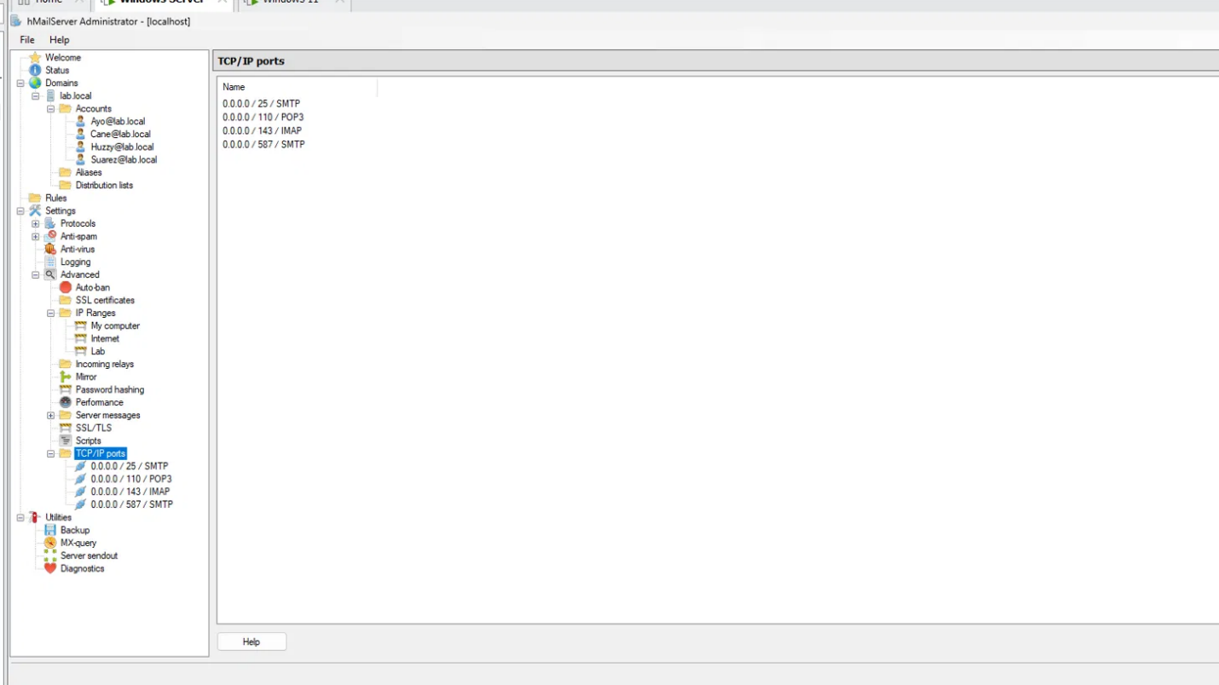

hMailServer listening on the standard ports — SMTP 25, POP3 110, IMAP 143, submission 587. The firewall rule on DC01 opens these so clients can reach them.
Why it matters: SMTP is for sending; IMAP and POP3 are for reading. The difference between IMAP and POP3 is where the mail lives afterwards — IMAP keeps it on the server so it shows on every device, POP3 pulls it down onto one machine. This lab uses IMAP.
Part 6 — Set up eM Client (10 min)
eM Client is the email program on the client machine, the equivalent of Outlook. Do this once for each mailbox; to use both mailboxes on one PC, add both accounts.
- Install and open eM Client on the client PC.
- When it asks for an email address, type john@lab.local and click Next.
- eM Client will try Automatic setup and fail. This is expected — there is no public autoconfig for a private lab domain, so it cannot guess the settings. Choose to set it up manually (“Set up manually” / “Other” / “Mail - Other” depending on the version).
- Enter the settings below.
Setting | Value
Account type | IMAP
Incoming (IMAP) server | mail.lab.local, port 143, security None/Off
Outgoing (SMTP) server | mail.lab.local, port 25, security None/Off
Username | john@lab.local (the full address, not just john)
Password | the mailbox password from Part 4
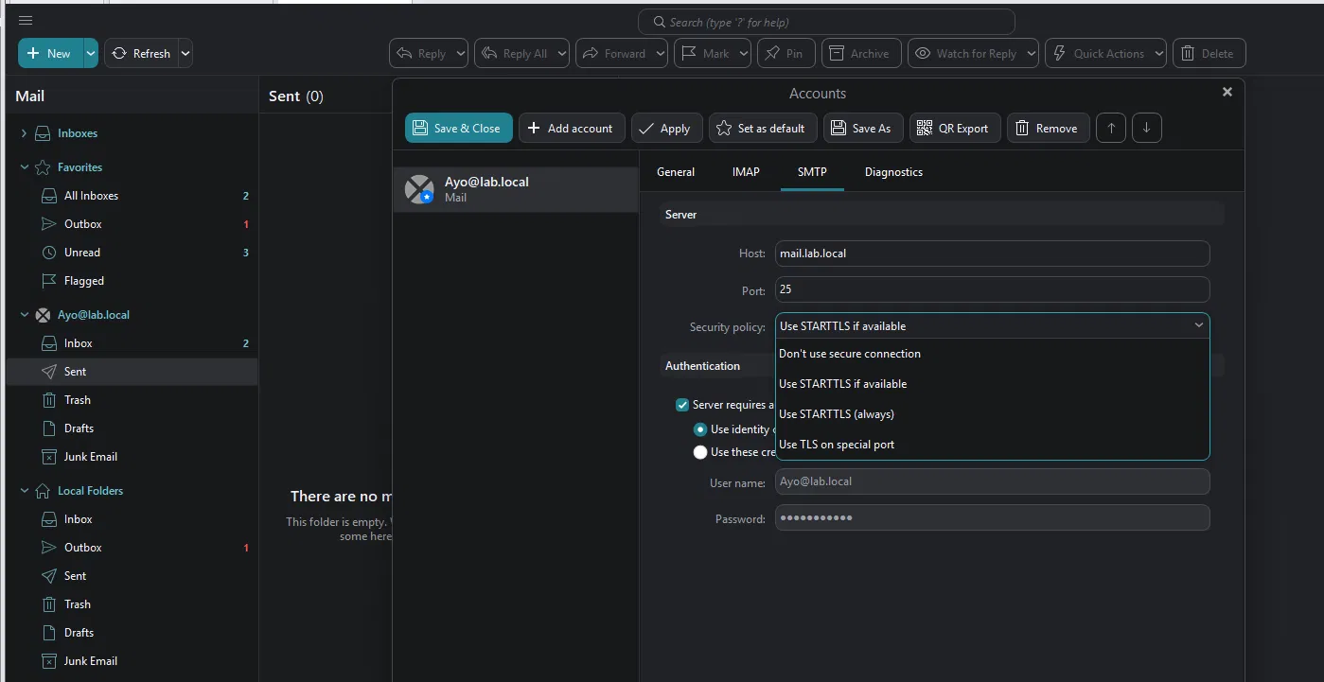

The SMTP settings in eM Client: mail.lab.local, port 25. Because the lab server has no certificate, the security policy must be Don't use secure connection — picking a STARTTLS option here is what leaves mail stuck in the Outbox.
- eM Client will warn that the connection is not encrypted. Accept it for the lab. In production you would use IMAP on 993 and SMTP on 587, both with TLS encryption, so passwords and mail are not sent in plain text.
- Finish. Repeat from step 1 for mary@lab.local, on the other PC or as a second account.
Why it matters: the failed automatic setup is useful, not a problem. It is why the server names and ports have to be understood at all. Big providers like Gmail publish autoconfig so it “just works”; a private lab domain does not, so you fill it in by hand — which is exactly what makes those settings meaningful.
Part 7 — The test that proves it works (5 min)
This is the payoff — the moment the whole build proves itself.
- In John's eM Client, click New message.
- To: mary@lab.local. Add a subject and a line of text. Click Send.
- Watch Mary's eM Client. Within a second or two the message lands in her Inbox.
- Have Mary Reply. It arrives back in John's inbox.
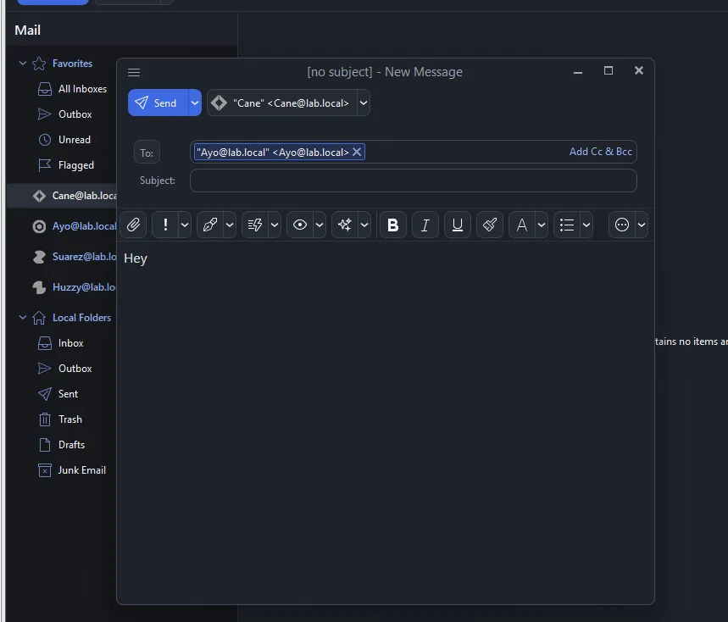
Composing from Cane@lab.local to Ayo@lab.local — the moment of truth.
That round trip — mail flowing between two accounts on a server built from scratch — is the proof that DNS, the mail service, and the client are all working together.
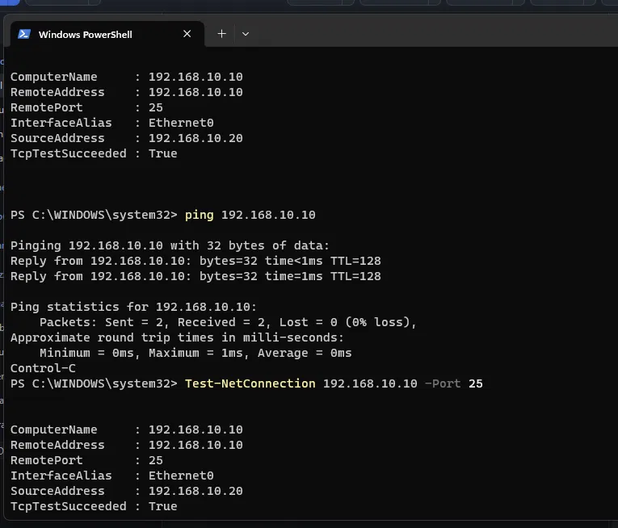
Proving the path from the client: Test-NetConnection 192.168.10.10 -Port 25 returns TcpTestSucceeded : True — the client can reach the mail server's SMTP port.
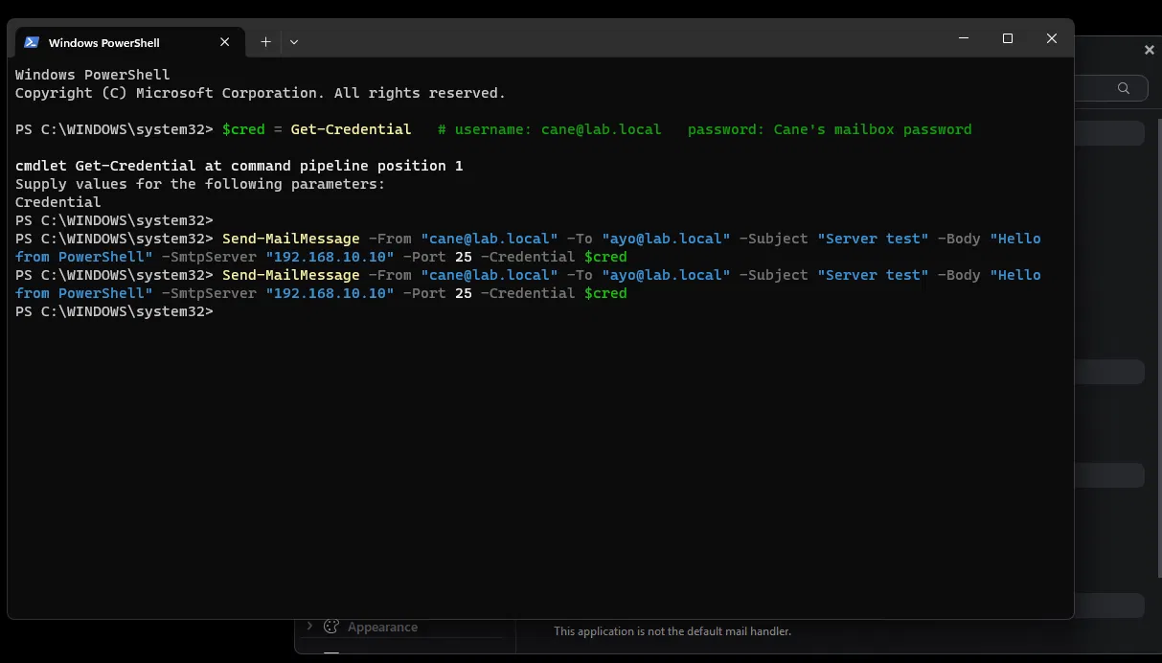
A send straight from PowerShell: Send-MailMessage returns silently, which means success — a clean way to prove the server accepts and delivers mail independently of any client.
tr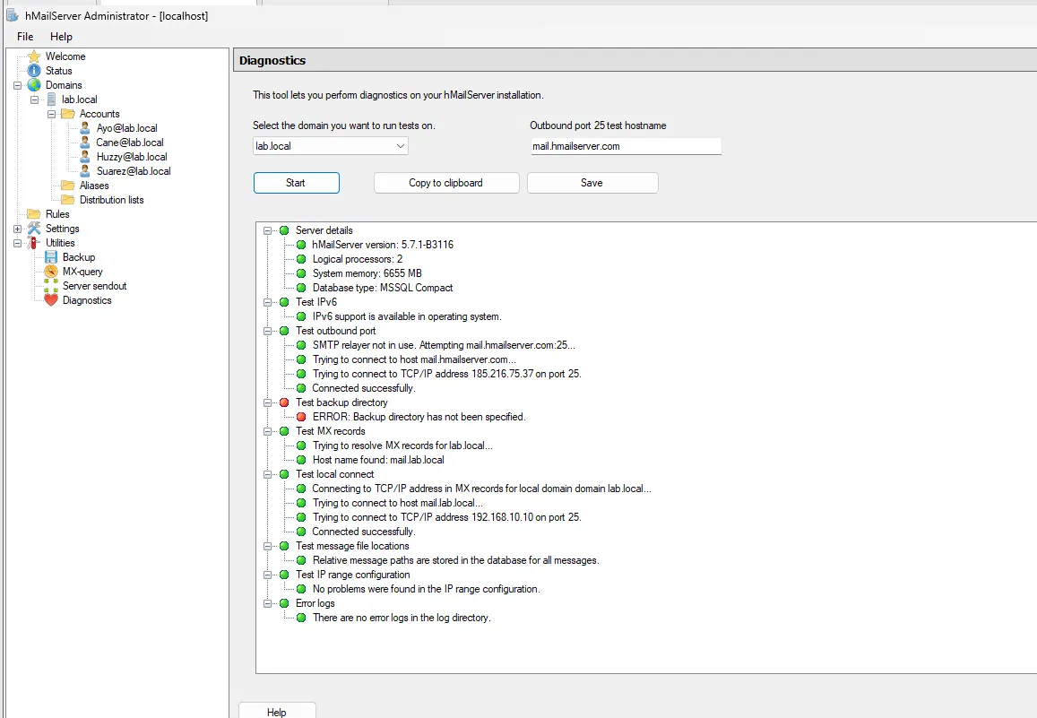
The server's own Diagnostics (Utilities → Diagnostics), all green for lab.local: MX records resolve, the local connect on port 25 works, IP ranges are fine. The single red line (backup directory not set) is separate housekeeping.
A useful test: try to email an outside address like someone@gmail.com. It fails with a relay or delivery error — and that is correct: a lab server only delivers to its own domain and has no route to the public internet. It is a good lead-in to how real mail servers relay to each other.
Troubleshooting (keep this handy)
Half the work is fixing what breaks. When something fails, work from the bottom up: network first, then DNS, then the mail service. These are the faults that come up most.
Symptom | Likely cause | How to check / fix
eM Client can't connect at all | Firewall port closed, or wrong server name | On the client: Test-NetConnection mail.lab.local -Port 143. If it fails, recheck Part 5 and the A record
Name won't resolve | Client's DNS isn't pointing at the DC | nslookup mail.lab.local on the client. Its DNS server must be the DC's IP
Mail sends but never arrives | hMailServer IP range not allowing delivery, or recipient mailbox doesn't exist | Part 4 step 3 (IP Ranges); confirm the mailbox name is spelled right
“Relay denied” / send refused | Trying to email an address outside lab.local | Correct behaviour. A lab server only delivers to its own domain
Login fails in eM Client | Username isn't the full address, or wrong mailbox password | Username must be john@lab.local, not john
Works on the server but not from a PC | Firewall, or the PC is on a different subnet than the allowed IP range | Recheck Part 5 and the IP range in Part 4
The Outbox trap (eM Client). A message that just sits in Local Folders → Outbox and never sends is almost always one of two things: it was composed against Local Folders instead of the account, or the SMTP security policy is set to a STARTTLS option against a server with no certificate. Compose from the account, set SMTP security to Don't use secure connection, and it clears.

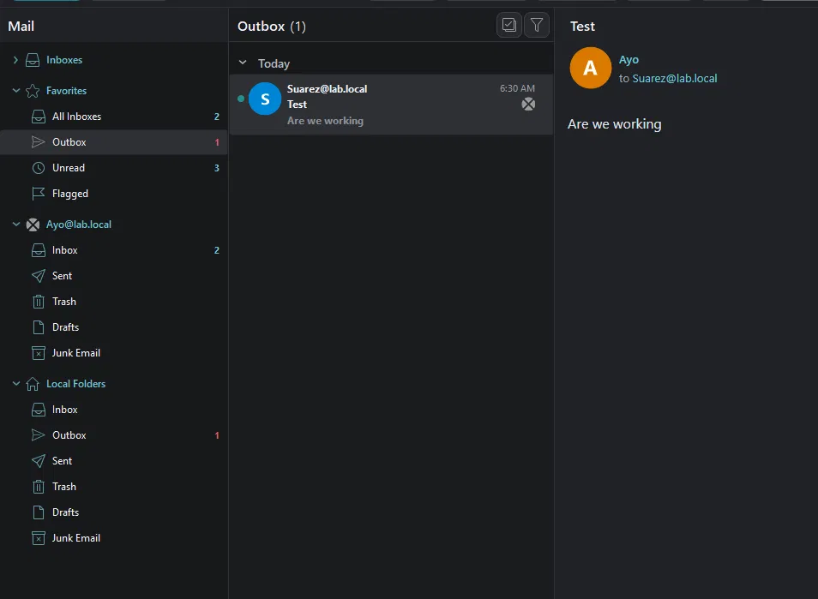
The symptom: a message stuck in the Outbox, never leaving.
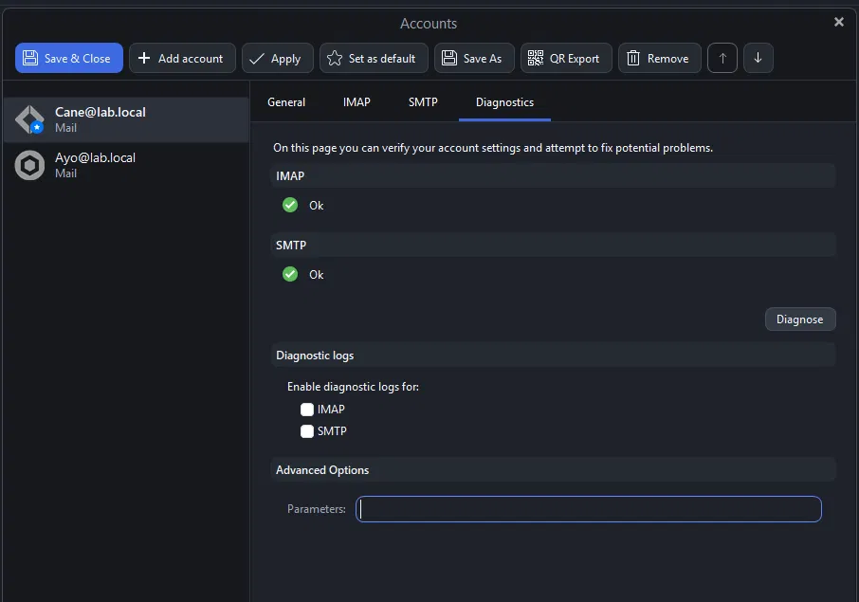

After the fix: the account's Diagnostics tab reports IMAP Ok and SMTP Ok — both ends healthy.
The troubleshooting order that always works: “can the PC even reach the server?” (Test-NetConnection), then “can it find the name?” (nslookup), then “is the mailbox right?”. Working in that order — network, then name, then service — is the real skill.
The ideas that matter
The concepts behind the clicks, worth keeping in mind:
- Lab vs production. Running mail on a domain controller, using no encryption, and locking down nothing — all fine for learning, all wrong for a real network. The production version is a dedicated mail server, TLS on ports 993 and 587, and a proper certificate.
- The two DNS records are the whole trick. MX says which server, A says where it is. Understand this pair and you understand how all email delivery finds its destination.
- Ports tell you the job. 25 sends, 143/993 read with IMAP, 110/995 read with POP3, 587 submits with encryption. Knowing these makes troubleshooting fast.
- Two different passwords. The hMailServer admin password manages the server; each mailbox password is what the user types into the client. Keep them distinct from day one.
- Troubleshoot from the bottom up. Network, then DNS, then the service. Most “mail is broken” problems are really a closed port or DNS pointing at the wrong server.
- Reliable free software for this lab: Windows Server 2025 Evaluation (180 days) and Windows 11 Enterprise Evaluation (90 days) from the Microsoft Evaluation Center; hMailServer from hmailserver.com; eM Client Free from emclient.com. hMailServer is older, unmaintained software — perfect for a closed lab, but it should not run on a live network.
When a VM has two network adapters: the DNS trap (dual-homing)
This one cost an evening in the lab, so it is worth documenting. If a VM has two network adapters — one on the isolated LAN Segment (for the domain) and one on NAT (for internet downloads) — the NAT adapter quietly breaks name resolution, and everything that depends on it (domain logon, mail sending) fails for no obvious reason. The server and client are fine; DNS is going to the wrong place.
Why NAT “overrides” the LAN Segment. The NAT adapter gets its IP address, its default gateway, and a DNS server automatically from VMware’s NAT service. Windows treats whichever adapter owns the default gateway as the “real” internet connection and sends DNS queries there first. So when a client looks up mail.lab.local, it asks NAT’s DNS — which has never heard of lab.local — instead of the domain controller. The lookup fails, and mail will not send even though the mail server is perfect. The LAN Segment adapter is still connected; Windows is just not listening to it for DNS.
Symptoms to recognise:
- Mail sits in the Outbox and will not send, but Test-NetConnection 192.168.10.10 -Port 25 succeeds and the server’s own diagnostics are all green.
- nslookup mail.lab.local fails or returns the wrong server on the client, even though it works on the DC.
- Intermittent domain logon problems on a machine that has both a NAT and a LAN Segment adapter.
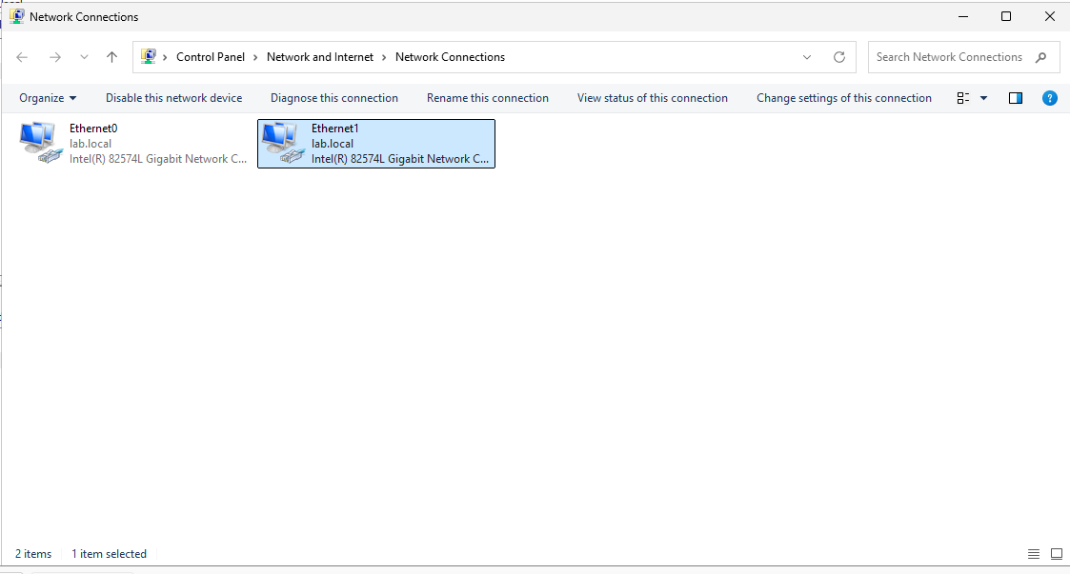

The dual-homed state: both adapters bound to lab.local. One is the isolated LAN, the other NAT — and the NAT one is quietly answering DNS.
The clean fix — don’t dual-home. A domain controller should have one adapter, on the LAN Segment, only — never give the DC a NAT adapter. When the DC needs the internet to download software, switch its single adapter to NAT, download, then switch it back. A client does not need the internet for this lab either, so the simplest rule is: one adapter on the LAN Segment.
If a client genuinely needs internet and the domain at once, keep both adapters but force Windows to prefer the DC for DNS. In an elevated PowerShell on the client:
Get-NetAdapter # note the two names, e.g. Ethernet0 (LAN) and Ethernet1 (NAT)
Set-NetIPInterface -InterfaceAlias "Ethernet0" -InterfaceMetric 10 # LAN = preferred
Set-NetIPInterface -InterfaceAlias "Ethernet1" -InterfaceMetric 50 # NAT = less preferred
ipconfig /flushdns
The LAN adapter must have its Preferred DNS set to the DC (192.168.10.10) and no gateway; the NAT adapter keeps DHCP for internet. After the metric change and the flush, nslookup lab.local resolves to the DC and mail sends immediately. (This split is fine on a client; never do it on a DC.)
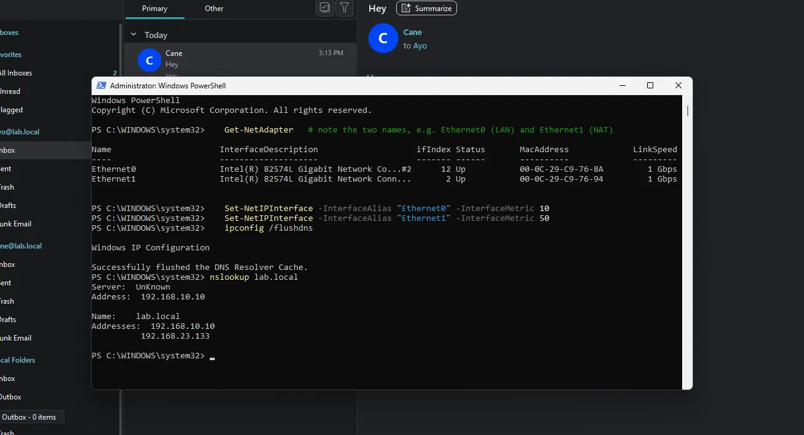
The smoking gun: nslookup lab.local returns two addresses — the real DC (192.168.10.10) and a stray NAT-side address (192.168.23.133). Lowering the LAN adapter's interface metric to 10 and raising the NAT adapter's to 50, then ipconfig /flushdns, makes the client prefer the right one.
Clean up the DNS pollution it leaves behind. A dual-homed client often registers its NAT address into the domain’s DNS, so nslookup lab.local starts returning two addresses — the DC (192.168.10.10) and a stray NAT address (e.g. 192.168.23.133) that leads nowhere and causes random failures later. Remove it:
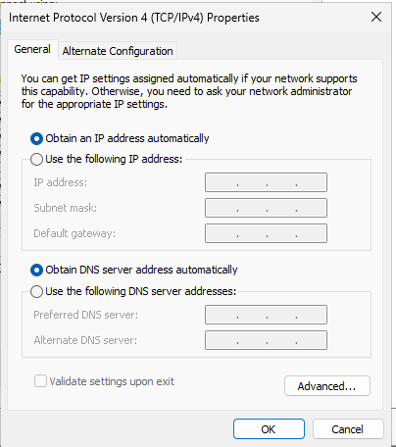
The cleaner fix: set the NAT adapter back to automatic (DHCP, no static DNS) so it stops competing to answer lab.local at all.
- On the client’s NAT adapter: Properties → IPv4 → Advanced → DNS tab → untick “Register this connection’s addresses in DNS.”
- On the DC: DNS Manager → Forward Lookup Zones → lab.local → delete the stray (same as parent folder) Host (A) record pointing at the NAT subnet. Keep the 192.168.10.10 one.
- On the client: ipconfig /flushdns then ipconfig /registerdns. nslookup lab.local should now return only the DC.
The rule to remember: when something on a domain “works on the server but not the client,” suspect DNS and adapter priority before anything else. Most domain problems are really the client asking the wrong DNS server — and a second (NAT) adapter is the most common reason it does.
Chapter 2 — Active Directory: OUs, groups, file sharing & GPOs (lab.local)
This chapter covers the second lab: Active Directory groups and their scopes, how file shares and NTFS permissions work together, mapping drives automatically with Group Policy, and locking down the computer itself with a baseline GPO. It uses the lab.local domain, the DC named DC, and three users — Ayo (Accounting), Huzzy (Banking) and Suarez (IT) — each in their own OU.
Build it in this order: groups first (they underpin everything), then the file server that uses them, then drive maps that deliver the shares, then the computer-side baseline. Every step was tested on a live client, and the screenshots below are from that build.
Understanding groups and their scopes
A group is a named list of people that you hang a permission on — like a bouncer’s clipboard. Anyone whose name is on the “VIP Room” clipboard gets in; nobody else. You add or remove a name on the list, never on the door. That is the whole reason groups exist: onboarding is “add a name,” offboarding is “remove a name,” and it affects every resource that list controls at once. Permissions given to a person are invisible and get orphaned; permissions given to a group are managed in one place.
Every group has a type (Security for permissions — always use this; Distribution is email-only) and a scope. The scope is the part people find hard. There are three, and each has one job:
Scope | Its one job | Can hold | Think
Global | Group people by role (Accounting, IT) | users from its own domain | “WHO they are”
Domain Local | Attach to one resource / permission | members from any domain | “WHAT they can reach”
Universal | Forest-wide roles across many domains | Global groups from any domain | multi-domain only
You pick the scope when you create the group (screenshot below). The key behaviour: scopes form a one-way funnel — Global → (Universal) → Domain Local → Permission. A Global group can be nested inside a Domain Local group, but a Domain Local group can never go inside a Global group — AD physically refuses it. That refusal is the lesson: Global is the input (people), Domain Local is the collector that touches the resource.
The scope is chosen here. DL_AccountingModifier is Domain Local (the resource collector); GG_Accounting is Global (the people).
AGDLP — and when it is overkill
AGDLP is the recipe that links a person to a resource, read as a sentence:
Account → into a Global group → into a Domain Local group → gets the Permission.
With our users: Ayo (account) is in GG_Accounting (Global), which is a member of DL_AccountingModifier (Domain Local), which has Modify on the Accounting folder. Read it backwards from the folder and it delivers the permission down to the human.
The nesting in practice: the Domain Local group DL_Banking contains the Global group GG_Banking (which contains Huzzy). The permission hangs on DL_Banking; the people arrive through GG_Banking.
When this actually matters. In a single small domain you can grant the Global group the folder permission directly and it works fine — you do not strictly need the Domain Local group at all. AGDLP earns its keep at scale and across multiple domains: it keeps “who someone is” (Global, managed where the person lives) separate from “what a resource allows” (Domain Local, managed where the resource lives), lets you audit one resource by looking at one group, and is the only clean way to share a resource across domains. It is a scaling discipline, not a hard rule for a tiny network.
The gotcha for any group: a user picks up new group membership only at their next logon (their access token is built at logon). A computer picks it up only at reboot.
NTFS vs Share permissions
Two separate permission systems guard a shared folder, and Windows applies the most restrictive of the two.
- Share permissions = the lock on the front gate of the building. They only apply when someone connects over the network (\\DC\Accounting). They do nothing to someone sitting at the machine.
- NTFS permissions = the lock on each room and drawer inside. They apply both over the network and locally, and they are granular (per folder, per file).
The professional habit: leave the Share side broad (Authenticated Users = Change) and do the real locking in NTFS. Managing two permission sets per folder is confusing, so you let NTFS carry the security and keep the share simple.
There is more to NTFS than this — inheritance, explicit vs inherited entries, Deny, the difference between Modify and Full Control, and the Effective Access tab. That is the next lab, and it will be added here as its own section.
For this lab we set the permission on the Share tab (which also works) to prove the group chain quickly; the production-correct approach is to grant the Domain Local group on the Security (NTFS) tab instead.
Building the department file server
1. Create the groups (in a Groups OU): a Global group per department — GG_Accounting (add Ayo), GG_Banking (add Huzzy) — and a Domain Local group per folder — DL_AccountingModifier, DL_Banking. Nest each Global group inside its matching Domain Local group.
2. Create the folders on the DC:
New-Item -Path C:\Shares\Accounting,C:\Shares\Banking -ItemType Directory
3. Share each folder (right-click → Properties → Sharing → Advanced Sharing → Share this folder → Permissions). Add the Domain Local group with Change, and remove Everyone.
The Domain Local group DL_Banking is granted Change on the share — this is the “P” of AGDLP landing on the resource. Only members of that group (via GG_Banking) can reach it.
4. Test from the client — the proof. Log in as Ayo and open \\DC\Accounting: it opens and she can create a file. Open \\DC\Banking: access denied, because she is not in the Banking chain.
Ayo blocked from Banking. The contrast — one department can’t see another’s folder — is the whole lesson: her name is on one list, not the other.
Troubleshooting: after a membership change the user must log off and back on. If access still looks wrong, use Properties → Security → Advanced → Effective Access, type the username, and Windows shows exactly what they can do.
Note on browsing: typing \\DC\Accounting works, but File Explorer → Network often shows nothing. That list is built by Network Discovery (off by default and unreliable). The direct path is the correct method; mapped drives (next section) are how real users reach shares.
NTFS permissions — the real lock on the file server
Share permissions are the door into the building; NTFS permissions are the lock on each room, stamped onto the file itself so they apply over the network and at the console. On this server all real control lives in NTFS — the Share stays open to Authenticated Users, and the Security (NTFS) tab does the work.
The six standard permissions, only three of which matter day to day:
Permission | What it allows
Read | See and open files; change nothing
Read & Execute | Read, plus run programs (bundles List folder contents)
Write | Create files/folders and write — but not delete
Modify | Read & Execute + Write + Delete. The everyday user permission
Full Control | Modify + change permissions + take ownership. Admins only
The trap: Modify vs Full Control. Hand out Modify. Full Control lets a user rewrite the lock itself — grant access to anyone and take ownership — which no ordinary user should do.
Start by reading the default ACL — and the leak it hides. A newly created folder inherits a default list that includes Users (every domain user) with Read. So before any hardening, the whole domain can read Banking at the NTFS level — the earlier “access denied” for Ayo was the Share door stopping her, not NTFS.
The default ACL on Banking: Users (LAB\Users) — i.e. every domain user — has Read & execute, List and Read. At the NTFS level the folder is wide open.
Inheritance — why the checkboxes are greyed. Every entry is either explicit (set on this object) or inherited (flowed down from the parent). Inherited entries are greyed and cannot be edited here; you would change them on the parent.
In Advanced, the Inherited from column reads C:\ — these rules came from the drive above, not from Banking. To edit them, inheritance must be broken first.
Break inheritance → make it explicit. Advanced → Disable inheritance → Convert inherited permissions into explicit permissions on this object. This keeps a copy of the current rules but makes them Banking's own, and editable.
After converting: Inherited from now reads None on every row and the button flips to Enable inheritance. The permissions belong to Banking now.
Lock it down to the right group. Remove both Users entries, then Add → DL_Banking → Modify (ticking Modify auto-selects Read & execute, List, Read and Write). Tick Replace all child object permission entries to push the clean list down into anything already inside. Leave SYSTEM, Administrators and CREATOR OWNER — they are plumbing.
The locked-down ACL: Administrators and SYSTEM (Full control), CREATOR OWNER, and DL_Banking = Modify. “Users” is gone — only the Banking group can now touch Banking, over the network or at the console.
The rules that resolve every conflict: precedence runs Explicit Deny → Explicit Allow → Inherited Deny → Inherited Allow, so an explicit Allow beats an inherited Deny — and Deny is a sledgehammer best avoided (not granting access already means no access). The Effective Access tab computes the final verdict for any user across share + NTFS + every group. Over the network the result is the most restrictive of Share and NTFS combined. And watch the move trap: a copy inherits the destination's permissions, a move on the same volume keeps the file's original ones.
Why it matters: this is the step that turns “it looked secured” into “it is secured.” Until Users is removed from NTFS, the folder is readable by the whole domain no matter how tight the Share looks. NTFS is also the P in AGDLP — one clean permission (DL_Banking = Modify) on the resource, and membership of the Global group decides who gets it.
Breaking inheritance in practice — a private sub-folder
The real proof of inheritance is a sub-folder that is more restrictive than its parent. HR_PRIVATE lives inside Banking, yet a Banking user cannot open it — because being inside a folder does not grant access. Each object carries its own lock.
The setup. Create HR_PRIVATE inside Banking and an HR_Private group, then on the sub-folder: Advanced → Disable inheritance → Convert, remove DL_Banking, and Add → HR_Private → Modify. The sub-folder's list now shares nothing with its parent.
HR_PRIVATE's own ACL after breaking inheritance: HR_Private = Modify, and DL_Banking is gone. Every row is Inherited from None — this folder answers to nothing above it.
The proof — Effective Access. Without logging anyone out: Advanced → Effective Access → select Huzzy (a Banking member) → View effective access. Windows computes the final verdict across share + NTFS + every group Huzzy belongs to.
Effective Access for Huzzy on HR_PRIVATE: every permission returns a red ✗, “Access limited by File Permissions” — that is NTFS itself. Huzzy is in DL_Banking, not HR_Private, so inside this sub-folder he gets nothing.
What it means. Huzzy can still see the HR_PRIVATE folder in the Banking listing (he has List on the parent), but double-clicking it returns “Access is denied.” A locked room inside an unlocked hallway. That is the whole power of inheritance: a child can be more restrictive, less restrictive, or completely different from its parent. (In strict AGDLP the resource group would be DL_HR with a GG_HR of people nested inside — same pattern as Banking; the mechanism shown here is identical.)
Proven live from the client: signed in on PC01, double-clicking HR_PRIVATE inside the mapped Banking drive returns “Windows cannot access \\DC\Banking\HR_PRIVATE — you do not have permission.” The folder is visible (List on the parent) but shut (no rights on the child) — exactly what Effective Access predicted.
That is the NTFS story end to end: default leak → lock to the department group → a private sub-folder proven shut with Effective Access.
Mapping drives automatically with Group Policy
So users never type \\DC\... or browse Network, map the share to a drive letter at logon, and use Item-Level Targeting so each person gets only their department’s drive.
- Group Policy Management → right-click lab.local → Create a GPO and link it here → name it Drive Maps → Edit. (Drive maps are a User setting, so linking at the domain root covers users in every OU.)
- User Configuration → Preferences → Windows Settings → Drive Maps → right-click → New → Mapped Drive.
  - Action Update, Location \\DC\Accounting, Reconnect ticked, Label Accounting, Drive Letter B:.
  - Common tab → tick Item-level targeting → Targeting… → New Item → Security Group → LAB\GG_Accounting.
- Repeat for Banking: \\DC\Banking, drive K:, targeted at GG_Banking.
- On the client, as the user: gpupdate /force, then sign out and back in. Ayo gets B: (Accounting) and no K:; Huzzy gets K: (Banking) and no B:.
Notes: this is Group Policy Preferences (the modern replacement for logon-script net use). Item-Level Targeting is the superpower — one policy, many outcomes, driven by the groups already built. If a drive is missing: did the user fully log off and on (not just gpupdate)? Check gpresult /r for the GPO under Applied; re-check the targeting group; and use Action Update to avoid “mapped once then vanished.”
Computer objects and a security baseline
When a machine joins the domain, AD creates a computer account — the machine is a member of the domain, just like a user, with its own identity and auto-rotating password (this is the “trust relationship”; when it breaks you see “The trust relationship between this workstation and the domain failed,” fixed with Test-ComputerSecureChannel -Repair). The payoff is that Group Policy has two halves: User Configuration follows the person; Computer Configuration applies to the machine no matter who logs in.
Set it up: create a Workstations OU and move the client (PC01) into it — the default Computers container cannot have GPOs linked to it, which is why we use an OU.
PC01 moved into the Workstations OU, ready to receive machine-level policy.
Create the baseline GPO, link it to the Workstations OU, and set these under Computer Configuration:
- Auto-lock: Security Settings → Local Policies → Security Options → Interactive logon: Machine inactivity limit = 900 seconds.
- Logon banner: same list → Message title = Authorized Users Only, Message text = a notice.
- Firewall on: Windows Defender Firewall with Advanced Security → all three profiles On, inbound Block.
- Block USB: Administrative Templates → System → Removable Storage Access → All Removable Storage classes: Deny all access = Enabled.
The USB-block policy. Computer Configuration, so it applies to the machine for every user.
Apply and verify. On PC01: gpupdate /force, then reboot. The results:
The banner shows before anyone can log in — proof a Computer Configuration policy applies to the machine itself.
gpresult /r /scope computer confirms the baseline applied: PC01 is in OU=Workstations and “Workstations Baseline” is listed under Applied Group Policy Objects.
The troubleshooting trio: (1) rebooted? Computer policy and computer group membership both settle at boot. (2) gpresult /r /scope computer — is the GPO applied or filtered out? (3) If you used security filtering to a group, did you add Authenticated Users (Read) back on the Delegation tab? Forgetting that is the #1 “my GPO vanished” cause.
Mental model: a user object says who may log in and what follows them around; a computer object says this machine is trusted and here is how it must be configured regardless of who uses it. Together they are why a domain-joined PC is locked down before anyone even signs in.
A managed desktop wallpaper with Group Policy — and the UNC path gotcha
Goal: every user in an OU gets the same company wallpaper, set centrally, that they cannot change. It lives under User Configuration → Administrative Templates → Desktop → Desktop → Desktop Wallpaper.
The build:
- Put the image somewhere every client can reach. On the DC, create a folder (e.g. C:\Wallpaper), drop Team.jpg in it, and share it — \\DC\Wallpaper — with Authenticated Users granted Read.
- Create a GPO (e.g. Company Wallpaper), link it to the OU that holds the users, and under Desktop Wallpaper set Enabled, Wallpaper Name = the path, Style = Fill.
- On a client: gpupdate /force, then log off and back on.
Step 1 in practice: the Wallpaper folder shared as \\DC\Wallpaper, with Read granted so every client can pull the image over the network.
The gotcha that cost an hour. The first attempt put the local path C:\Wallpaper\Team.jpg in the policy. On the DC that path is real, so it looked right — but on a client machine C:\Wallpaper does not exist. Group Policy applies on the client, so the client reads that path against its own C: drive, finds nothing, and shows a black or default background. No error — just no wallpaper.
The mistake, in the GPO's own settings report: Wallpaper Name is C:\Wallpaper\Team.jpg — a local path. It looks right because it is real on the DC.
The file does exist — but only on the DC, at C:\Wallpaper. A client has no such folder, so Group Policy finds nothing and shows no wallpaper.
The fix: the path in the policy must be one the client can resolve from anywhere on the network — a UNC path: \\DC\Wallpaper\Team.jpg. The moment it changed from C:\… to \\DC\…, the wallpaper appeared on every client after a gpupdate and re-logon.
The key habit — the single most useful one in Group Policy: any file a GPO points at must be named by a path the client can reach, not a path that only exists on the server. The server sees its own C:\; the clients never do. It is the same lesson as the mapped drives (\\DC\..., never a drive letter that is local to the DC), and it catches everyone exactly once. When a GPO that “should work” does nothing and throws no error, suspect a path only the server can see.
Restricting web browsing with Group Policy
Goal: lock staff to an approved list of websites. The strict model is an allow-list — block everything, then permit only sanctioned sites — enforced through Group Policy, per browser.
Allow-list vs block-list. A block-list allows everything and blocks known-bad sites: loose, and you are always chasing new sites. An allow-list blocks everything and permits only approved sites: strict. This lab builds the allow-list.
Why “per browser” matters. Edge and Chrome are both Chromium and read the same policy names (URLBlocklist / URLAllowlist) — but under different paths, so setting one does not set the other. Firefox is a separate engine with its own setting (WebsiteFilter). And a browser policy only binds the browsers you lock — a portable browser or a VPN can slip past it. The only truly browser-agnostic control is the network layer (filtered DNS, a proxy, or a firewall); the browser GPO is the practical in-host layer. This lab covers Edge, Chrome and Firefox, and notes the network layer as the deeper wall.
Step 1 — Obtain the browser policy templates. Group Policy only exposes a setting if its ADMX template is loaded, and Edge's templates ship separately from Windows. From the Microsoft Edge for Business download page, use the Download Windows 64-bit Policy link — the small link under the browser's black Download button, not the browser installer.
The Edge for Business page. The Download Windows 64-bit Policy link (under the black Download button) is the ADMX pack — not MicrosoftEdgeEnterpriseX64.msi, which is only the browser installer.
Extract the ZIP; the templates live under windows\admx\.
Inside windows\admx: msedge.admx, msedgeupdate.admx, and a language folder (en-US) holding the matching .adml files. These are what go into the Central Store.
Step 2 — Seed the Central Store. The Central Store is the domain-wide home for ADMX templates: \\lab.local\SYSVOL\lab.local\Policies\PolicyDefinitions. Once templates live there, every admin editing a GPO sees them, and Group Policy reads “from the central store” instead of each machine's local copy. Seed it in two moves:
- Copy the whole built-in set first — C:\Windows\PolicyDefinitions → \\lab.local\SYSVOL\lab.local\Policies\ — so the store isn't missing Windows' own templates.
- Add Edge on top: msedge.admx + msedgeupdate.admx → …\PolicyDefinitions\, and their .adml files → …\PolicyDefinitions\en-US\.
Proof it worked: editing any GPO, Computer Configuration → Policies → Administrative Templates now reads “retrieved from the central store” and a Microsoft Edge node appears.
The seeded Central Store at \\lab.local\SYSVOL\lab.local\Policies\PolicyDefinitions — the built-in Windows templates (223 files) plus msedge.admx and msedgeupdate.admx dropped in, with their .adml files in en-US.
Templates loaded: the editor confirms “retrieved from the central store,” and Microsoft Edge (plus Microsoft Edge Update) now appears under Administrative Templates — ready to configure. Use the plain Microsoft Edge node, not “Default Settings (users can override).”
Step 3 — The rule: block all, then allow the approved list. Edit the Web Restriction GPO → Computer Configuration → Policies → Administrative Templates → Microsoft Edge (the enforced node, not “Default Settings (users can override)”). Two policies do the whole job, and the allow-list wins over the block-list.
1. Block everything — Block access to a list of URLs (URLBlocklist): Enabled → Show → one entry, *.
Block access to a list of URLs = Enabled, with the single value * — that blocks every site. Edge's own help note confirms the allow-list overrides it.
2. Allow the approved sites — Define a list of allowed URLs (URLAllowlist, older name “Allow access to a list of URLs”): Enabled → Show → the sanctioned sites, one per line.
Define a list of allowed URLs = Enabled, listing microsoft.com, bing.com, lab.local. These override the * block, so they are the only sites that load. “The allowed list takes precedence over the blocked list.”
That is the complete allow-list: URLBlocklist = * plus an URLAllowlist of the sites the business sanctions. Note from Edge's help: the most specific filter wins, so company.com/reports can be allowed while the rest of a site stays blocked.
Step 4 — Test on the client. On PC01: gpupdate /force, then open Edge. An approved site (bing.com) loads; anything else is refused with Edge's “This page is blocked — your organization doesn't allow you to view this site.”
youtube.com on PC01 after the policy applied: “This page is blocked.” Only the allow-list loads. (A bare * also blocks Edge's own edge://policy page — add edge://* to the allow-list if you need internal pages.)
(Still to add below: Chrome + Firefox coverage via one registry-based GPO, and a note on the network layer — the Edge GPO only binds Edge.)
Firewall – Pfsense
Firewall-HQ
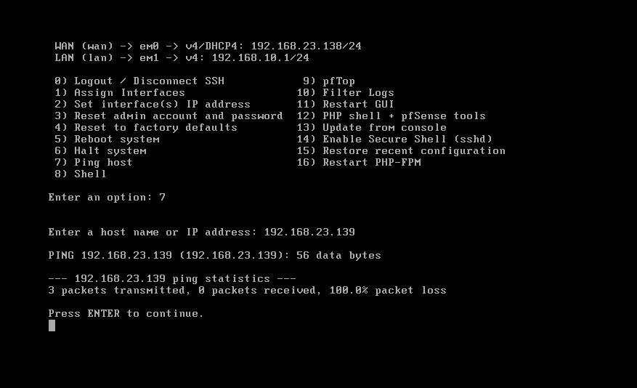
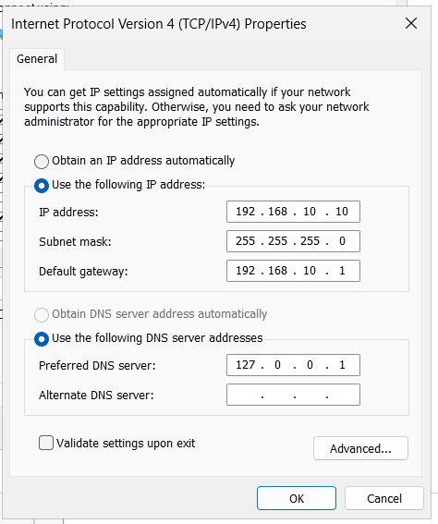

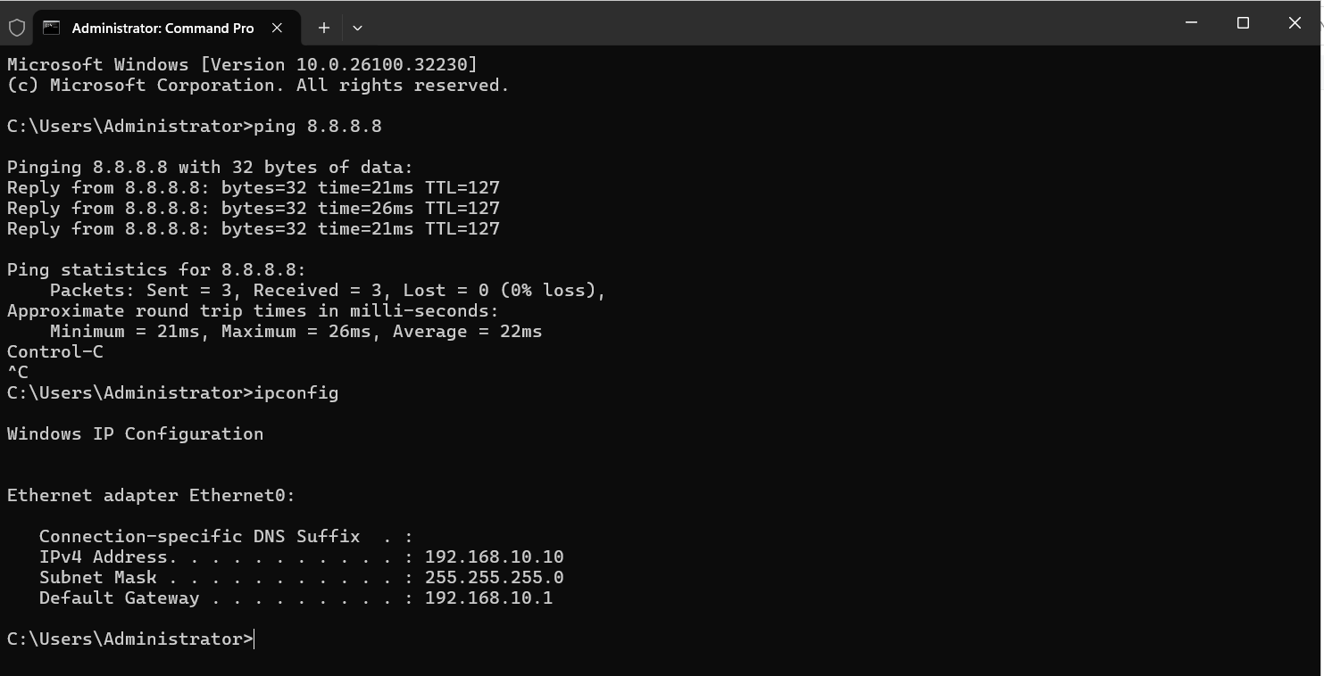

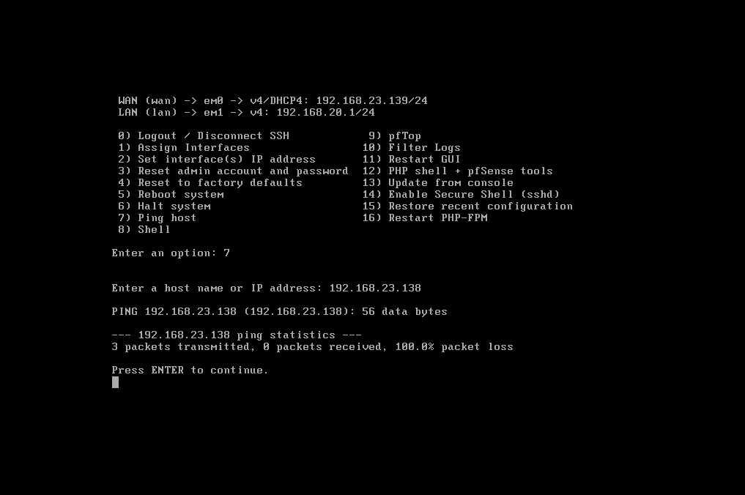
Client Machine
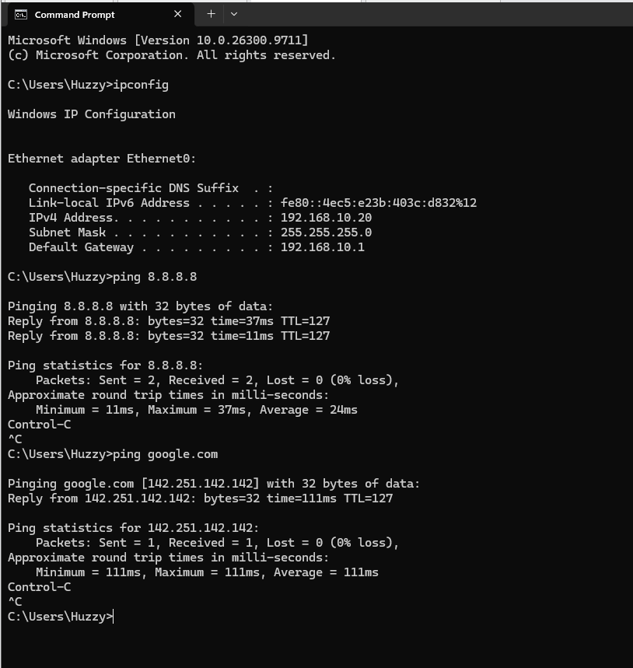
Domain Controller Access to PFsense
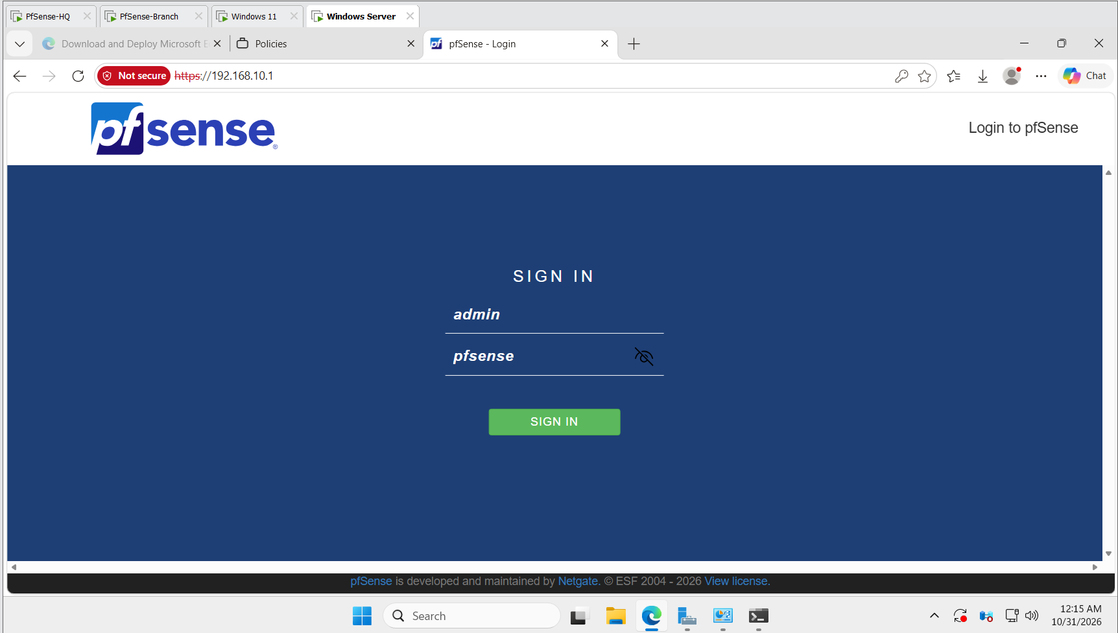
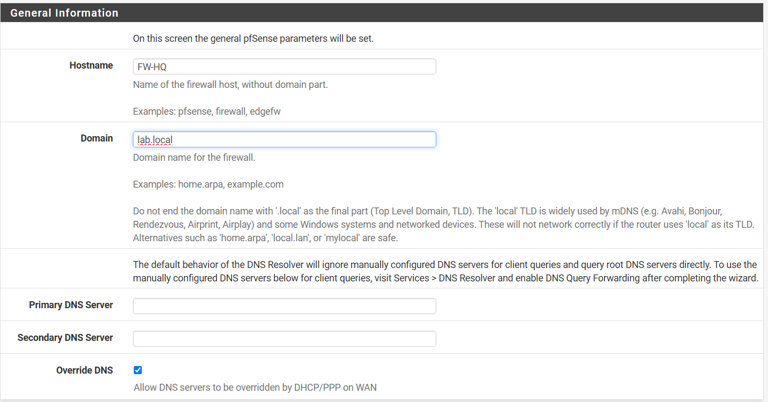

New Pass: PFSense123!
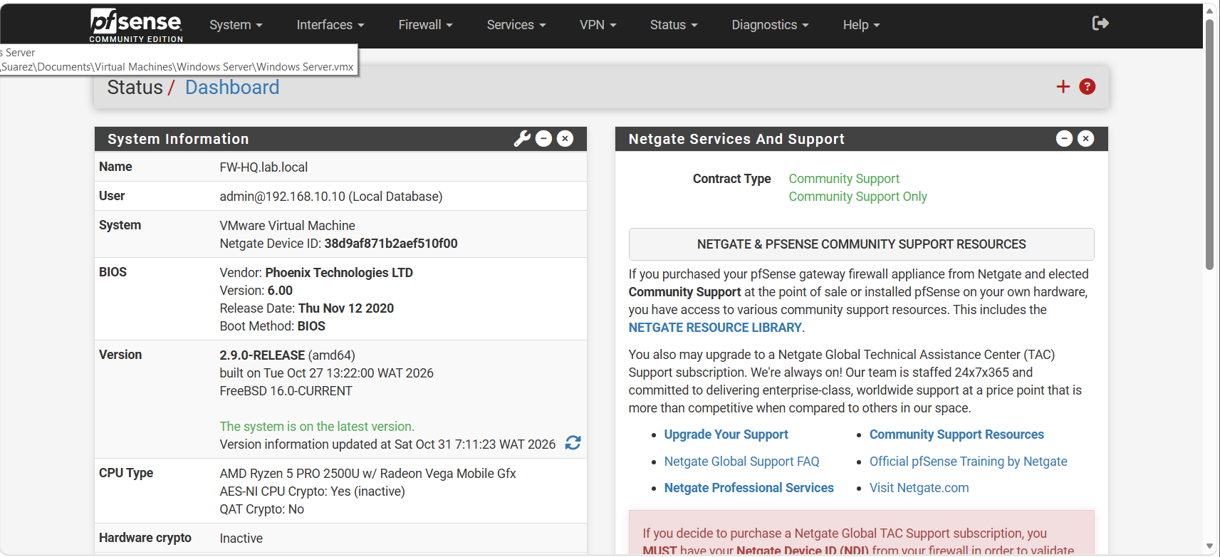

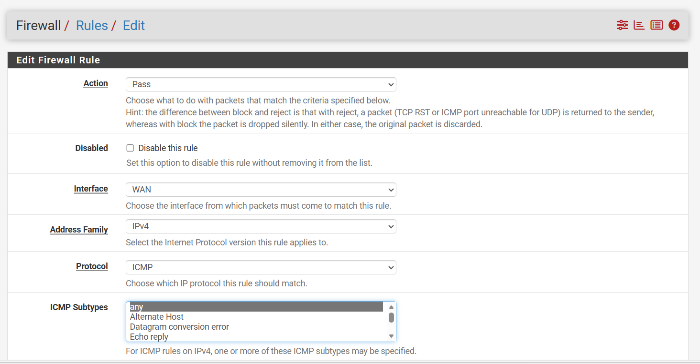
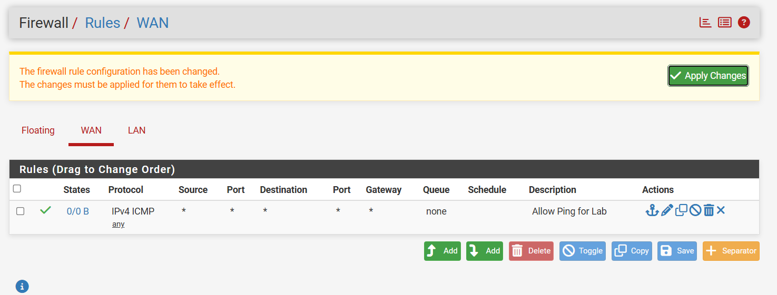

Branch PC
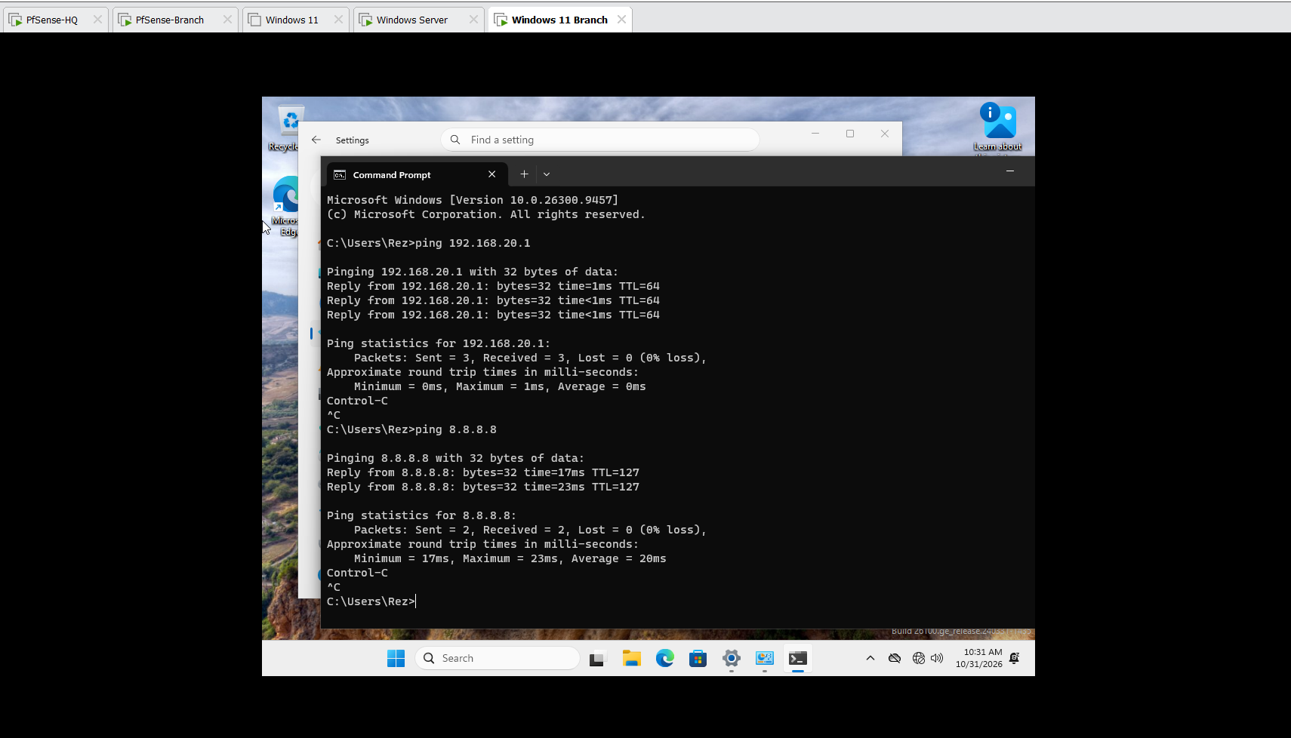
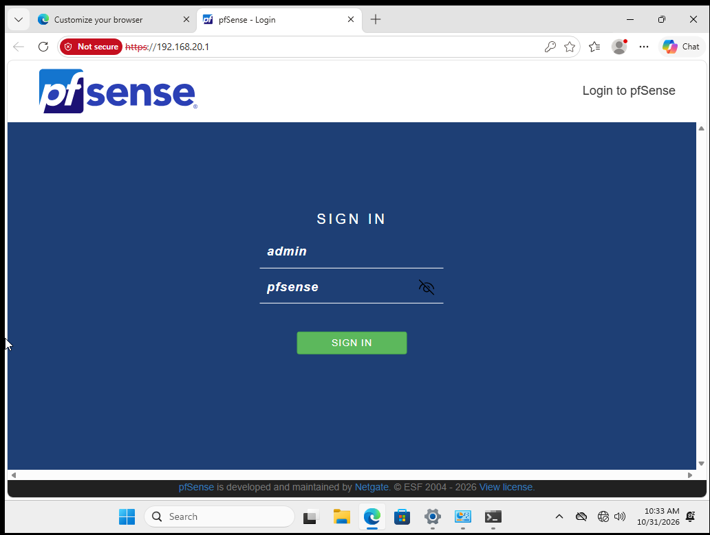

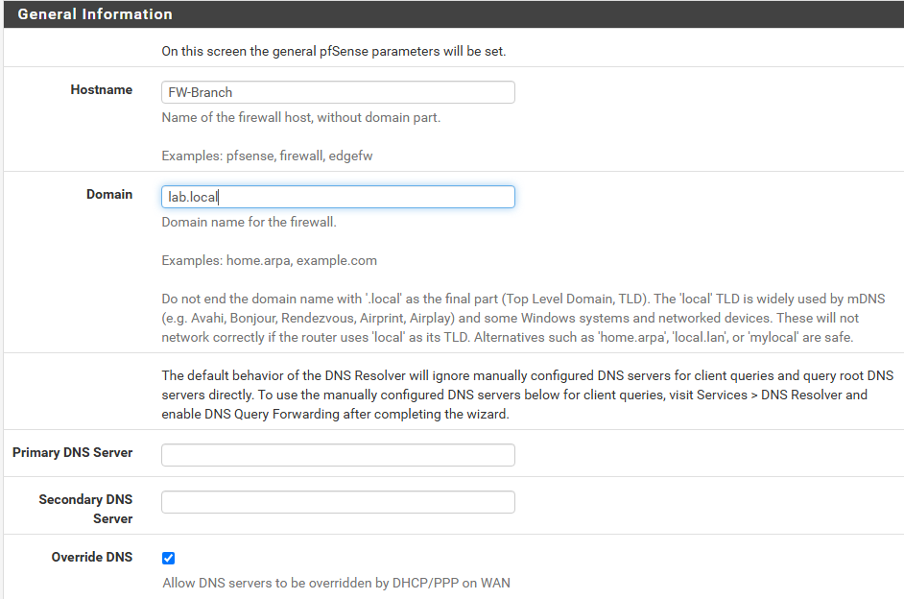

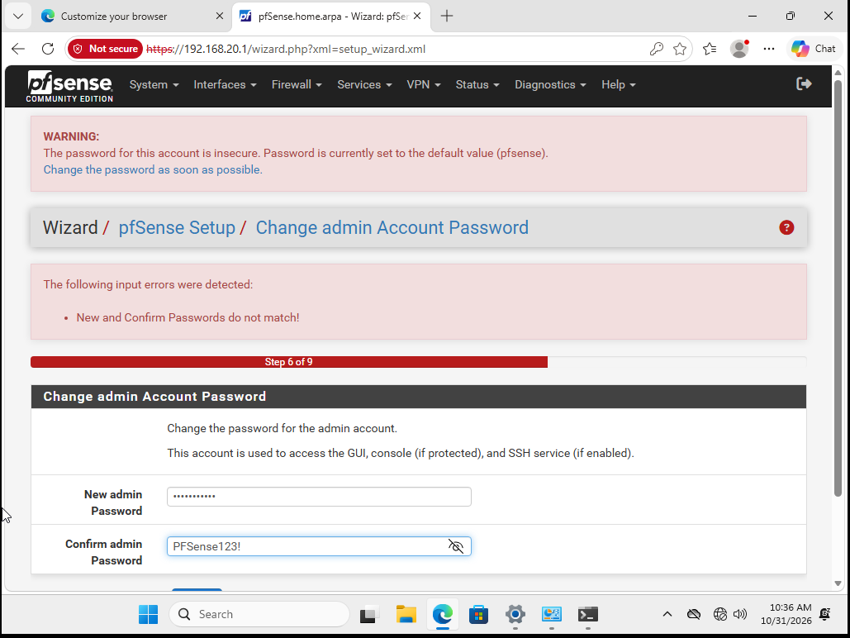
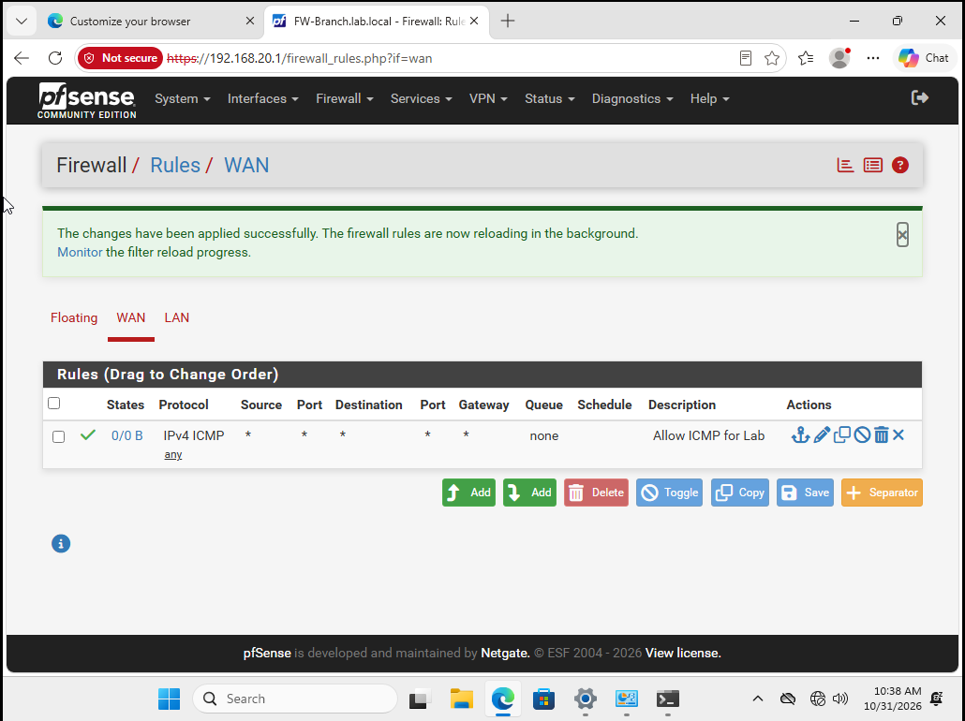
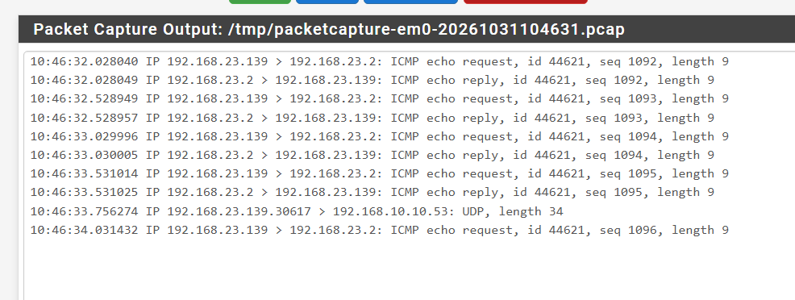
Troubleshooting
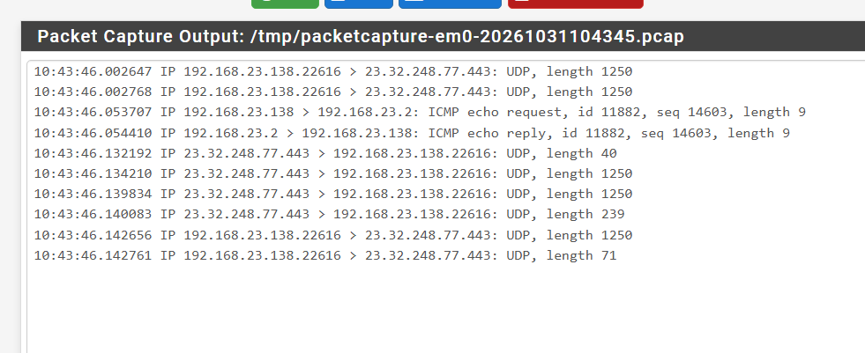

Remote Access

Install Network Policy Server in AD|DS Roles and Features
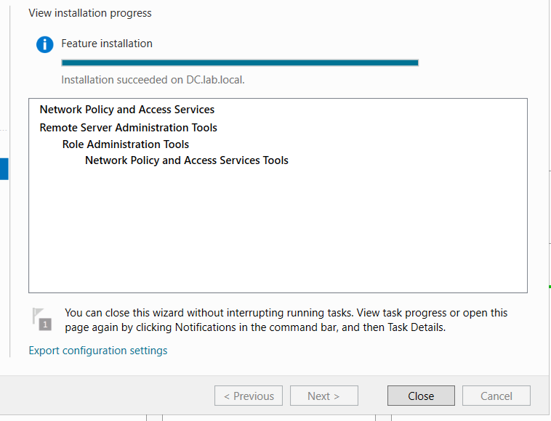
Register NPS in Active Directory: Open Network Policy Server (nps.msc) and Right-click NPS (Local) and click Register server in Active Directory.
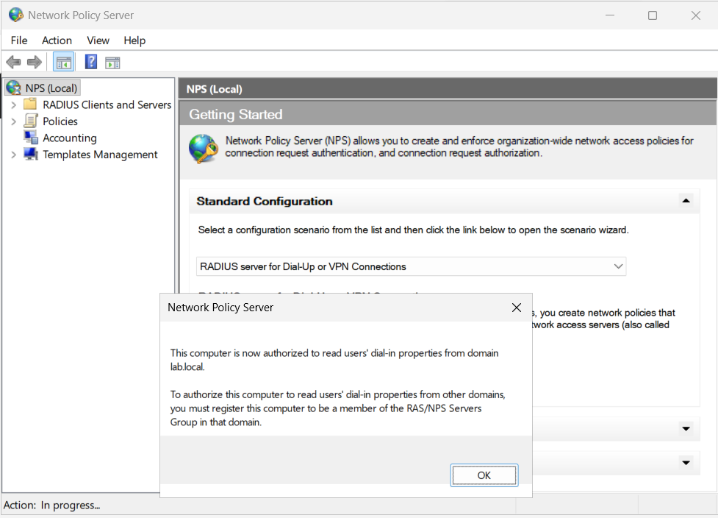
Add pfSense as a RADIUS Client: Expand RADIUS Clients and Servers > right-click RADIUS Clients > New. Friendly name: pfSense-HQ. Address (IP or DNS): 192.168.10.1 (pfSense LAN IP) Shared Secret: Set a password (Pass123).
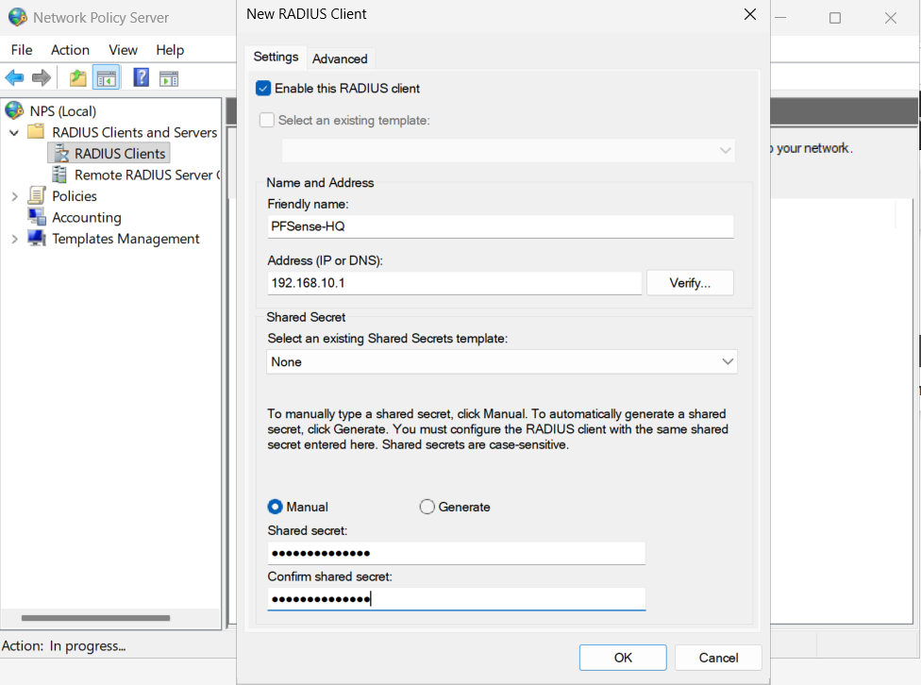

Create a Connection Policy: Expand Policies > right-click Network Policies > New. Policy name: VPN-Allow. Type of network access server: Unspecified. Conditions: Click Add > select User Groups > add an AD group containing your test account (or select Domain Users for lab testing). Access Permission: Select Access granted. Authentication Methods: Check Microsoft Encrypted Authentication version 2 (MS-CHAP-v2) and uncheck less secure methods. Finish the wizard.
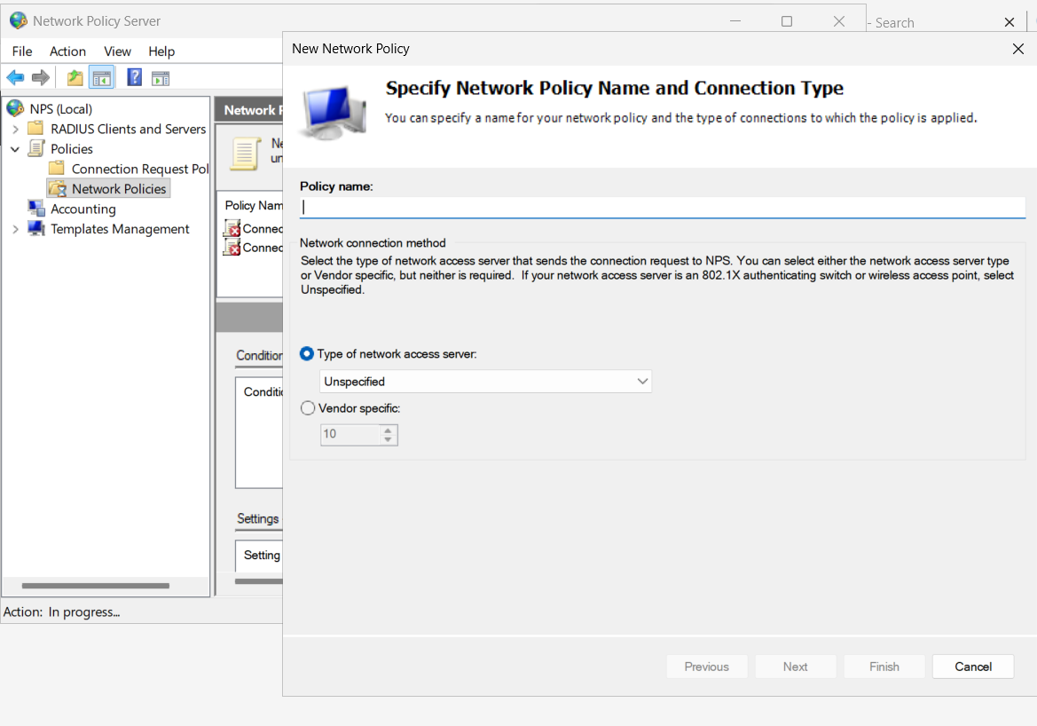

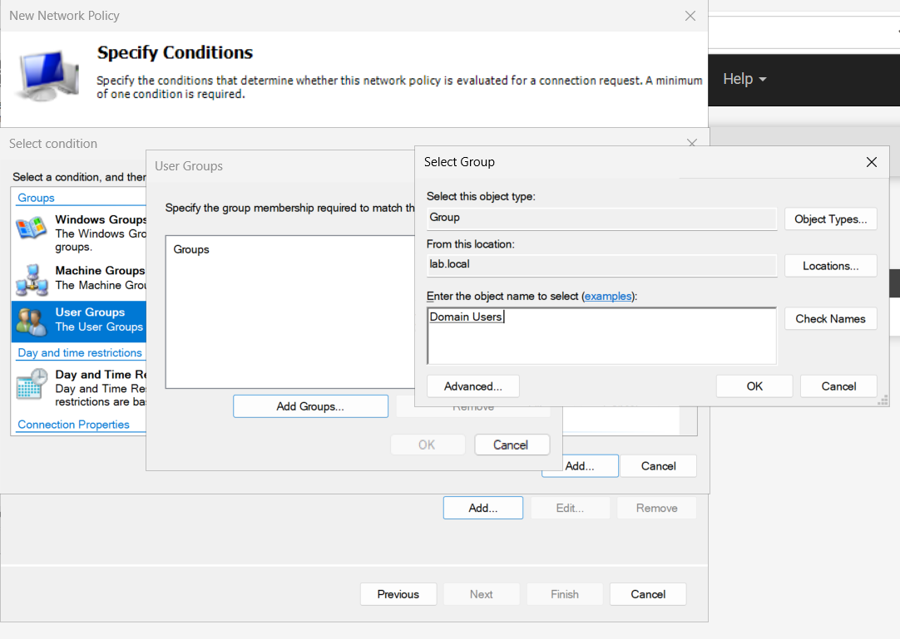
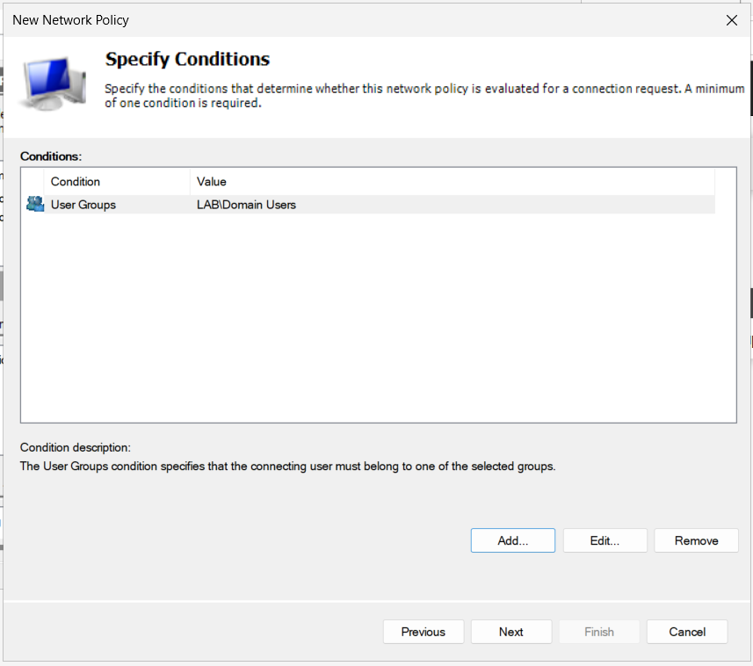

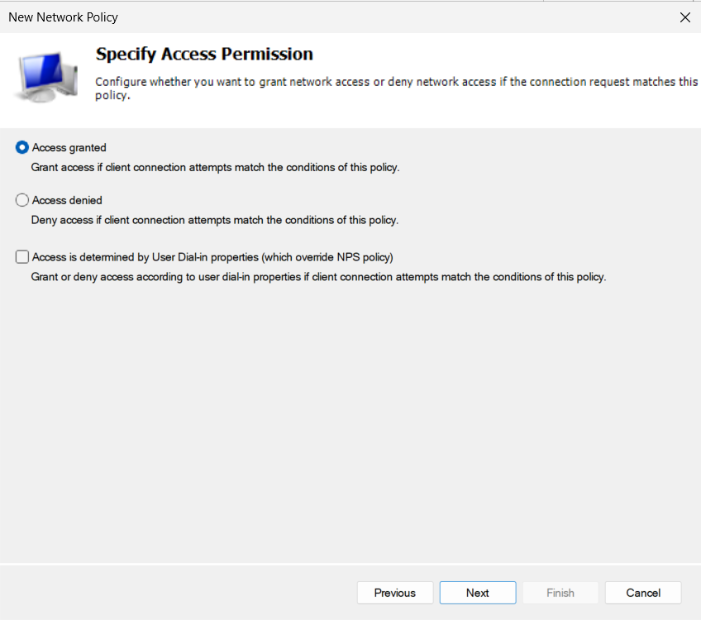

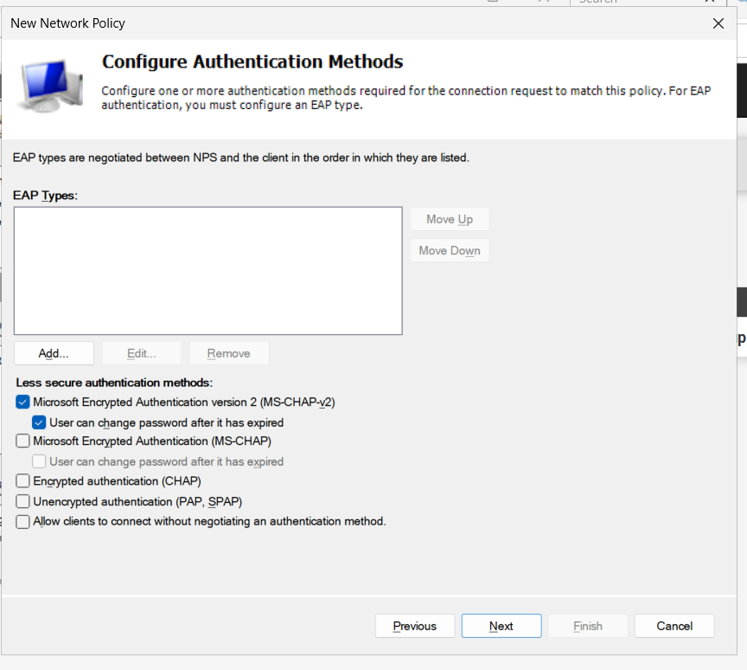
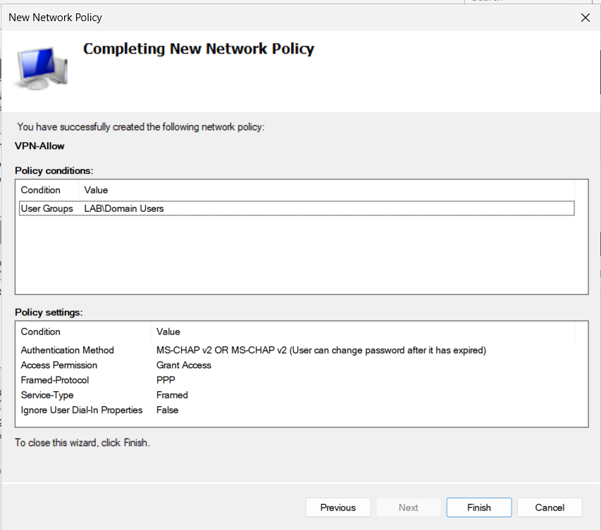

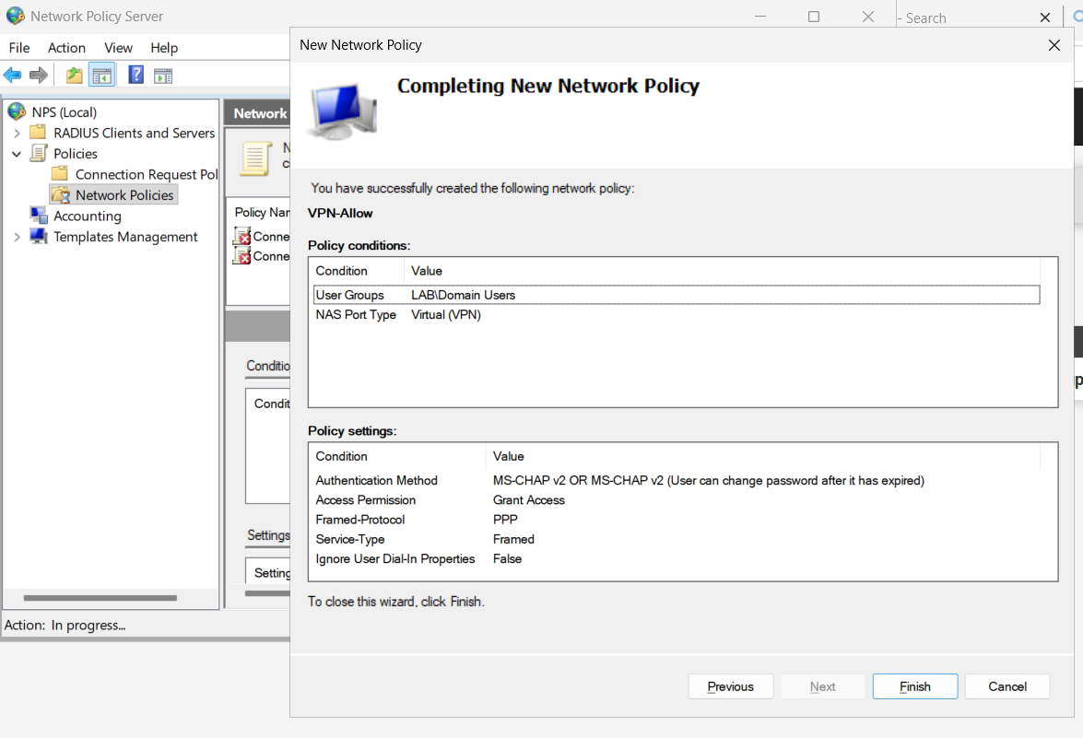
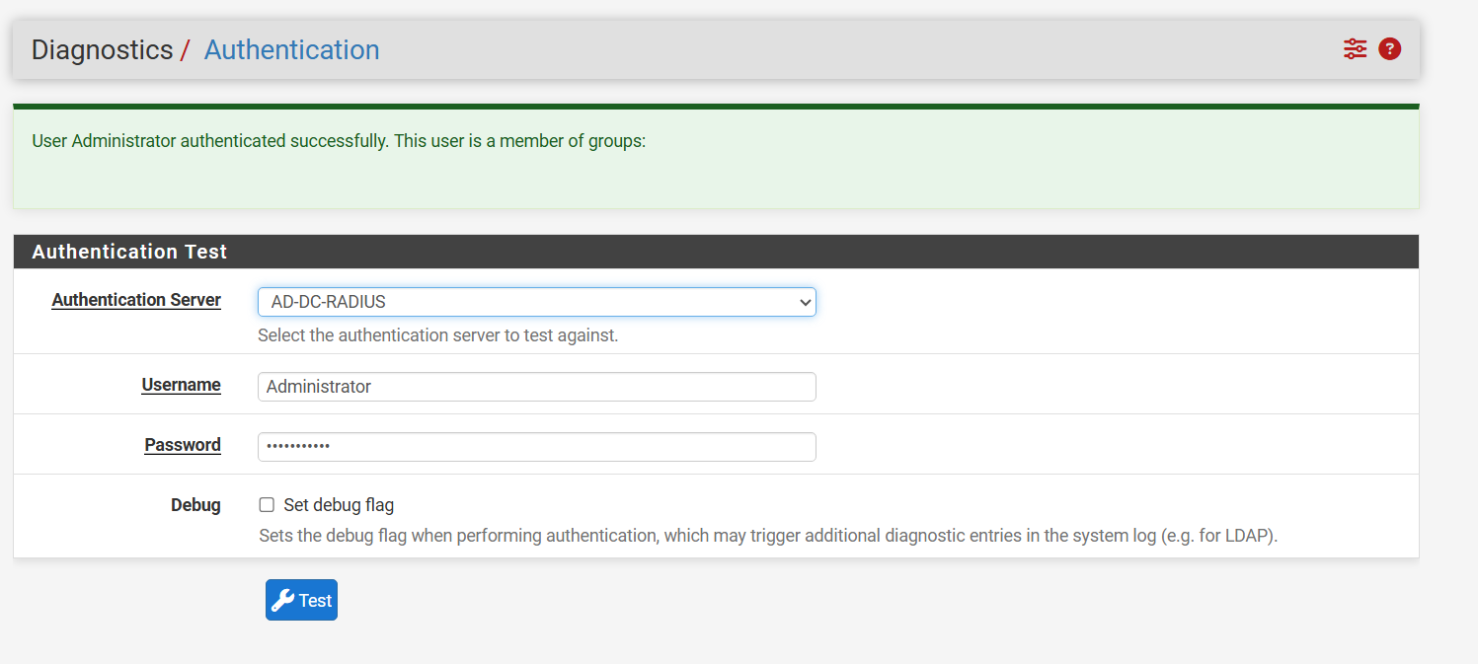

Certificates
Create the VPN Server Certificate: Navigate to System > Certificates > Authorities and click Add to create an internal CA (e.g., Lab-CA). Navigate to Certificates > click Add: Method: Create an internal Certificate. Certificate authority: Lab-CA. Certificate Type: Server Certificate. Common Name (CN): Your WAN IP (192.168.23.138) or public DDNS/FQDN. Alternative Names (SAN): Add IP Address = 192.168.23.138 (and DNS if using a hostname). Save the certificate, then return to System > Certificates > Authorities and click the Export CA icon to save Lab-CA.crt (you will need this on the remote client).

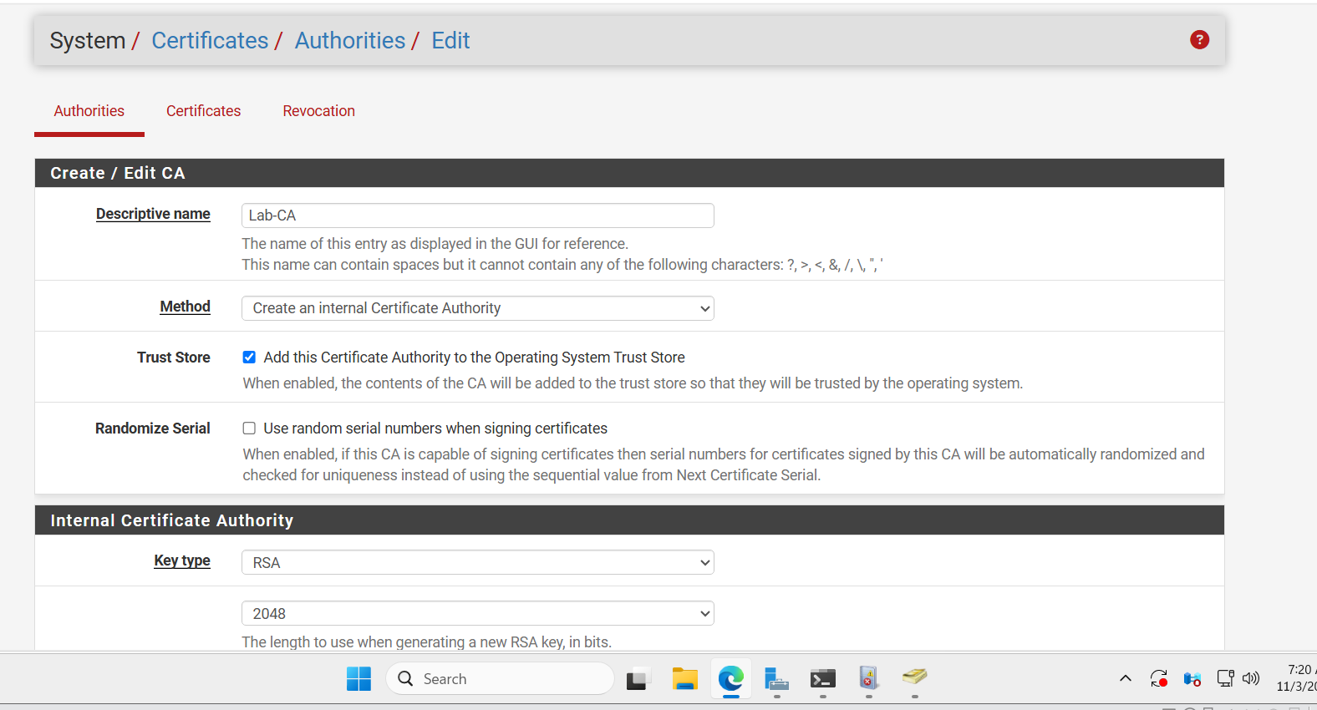

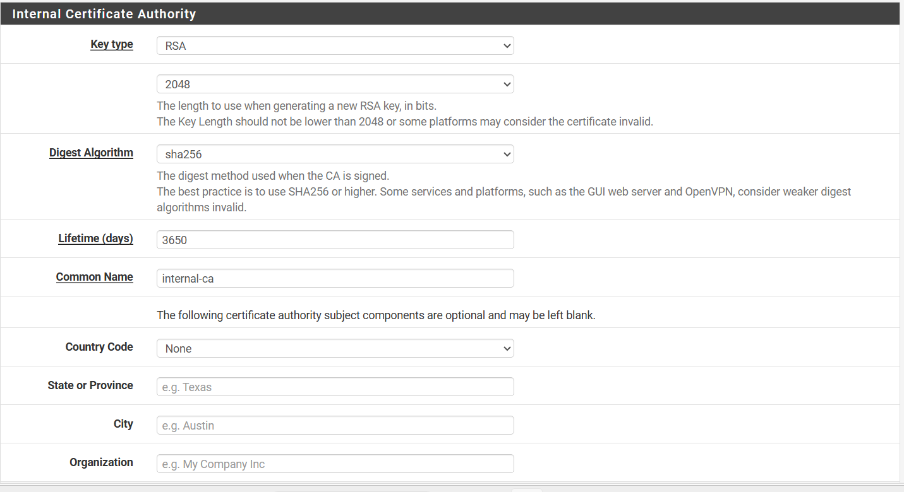
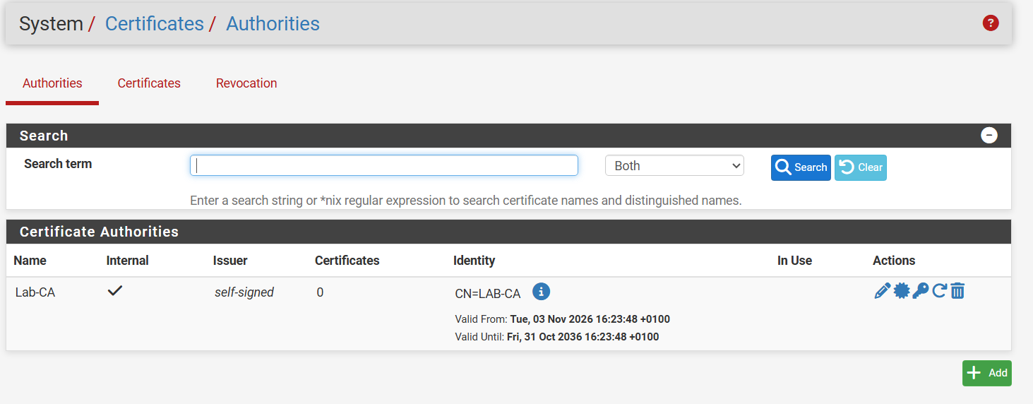

Cert
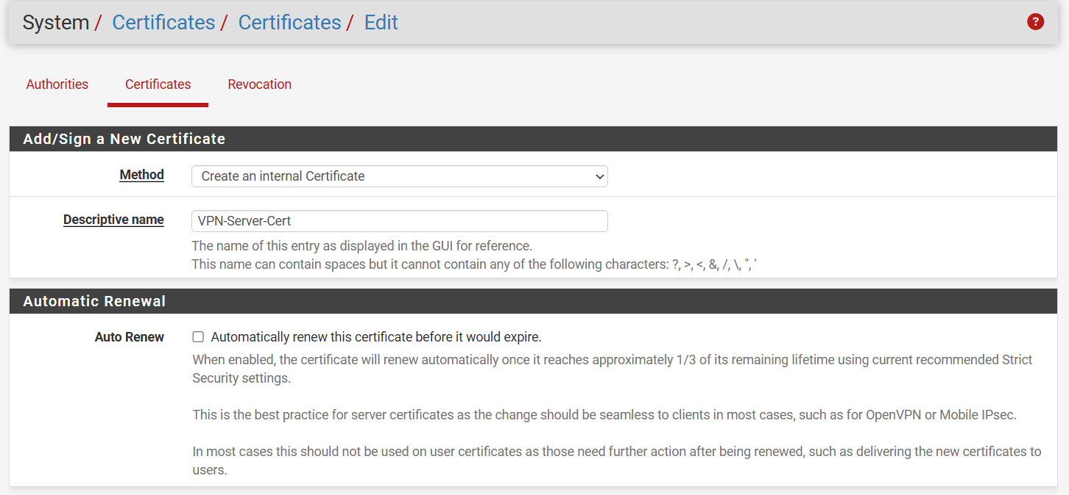
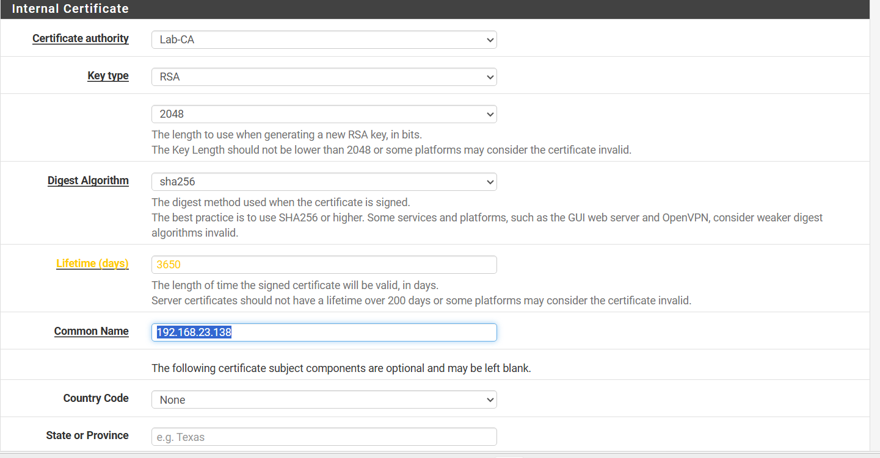
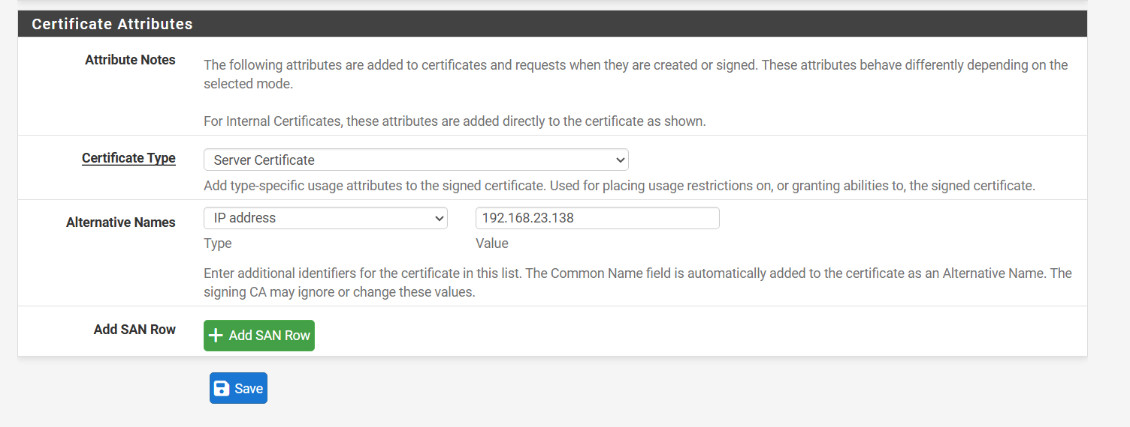

Step 4: Configure IPsec Mobile Clients and Phase 1 / Phase 2
Enable Mobile Clients: Go to VPN > IPsec > Mobile Clients tab. Check Enable IPsec Mobile Client Support. User Authentication: Select AD-DC-RADIUS. Virtual Address Pool: Check and enter an isolated pool (e.g., 10.10.100.0/24). DNS Servers: Check and enter 192.168.10.10. DNS Default Domain: lab.local. Save and Apply Changes.

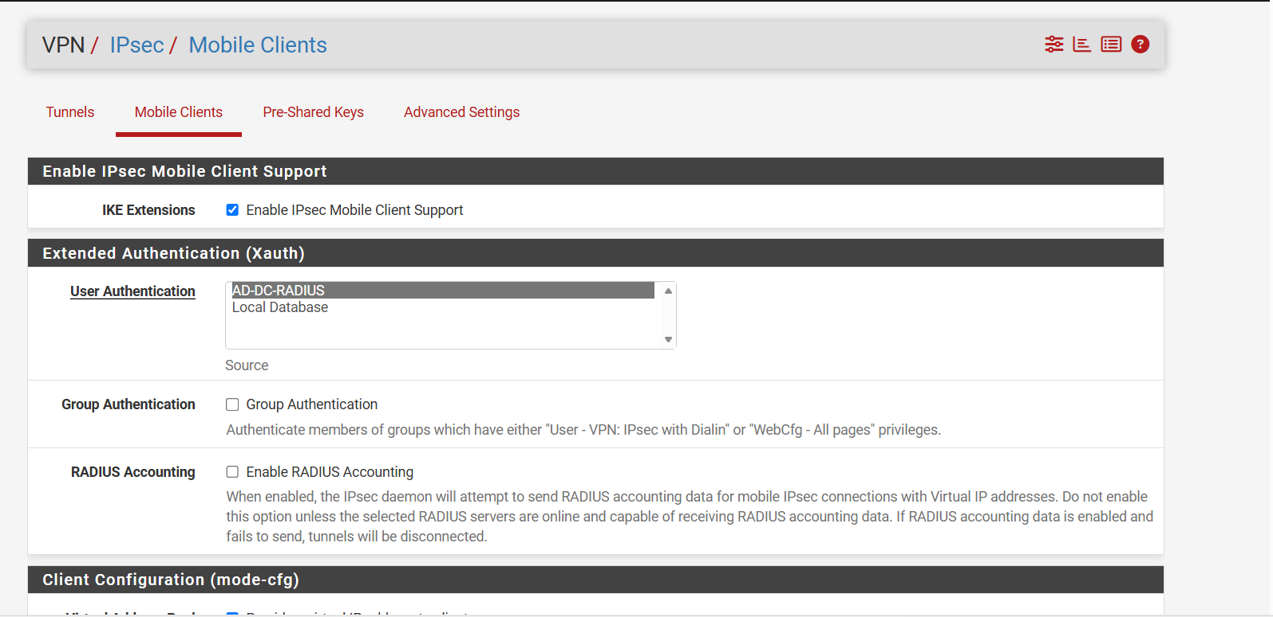

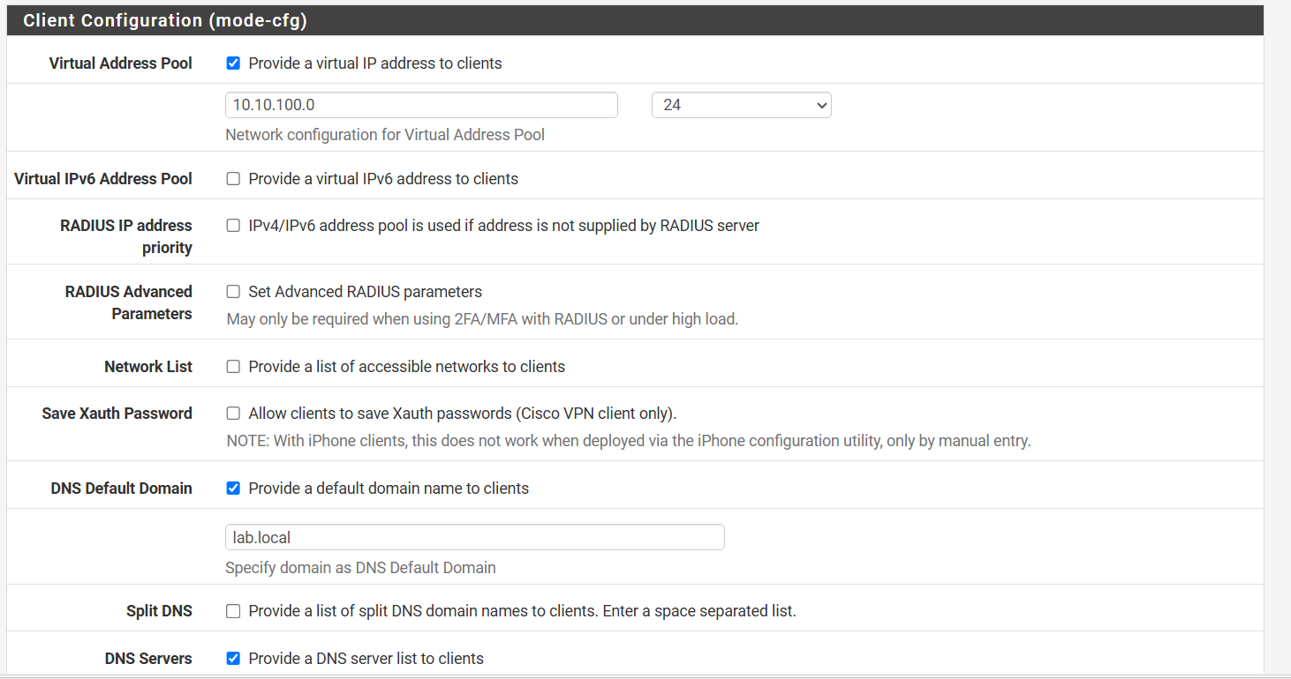

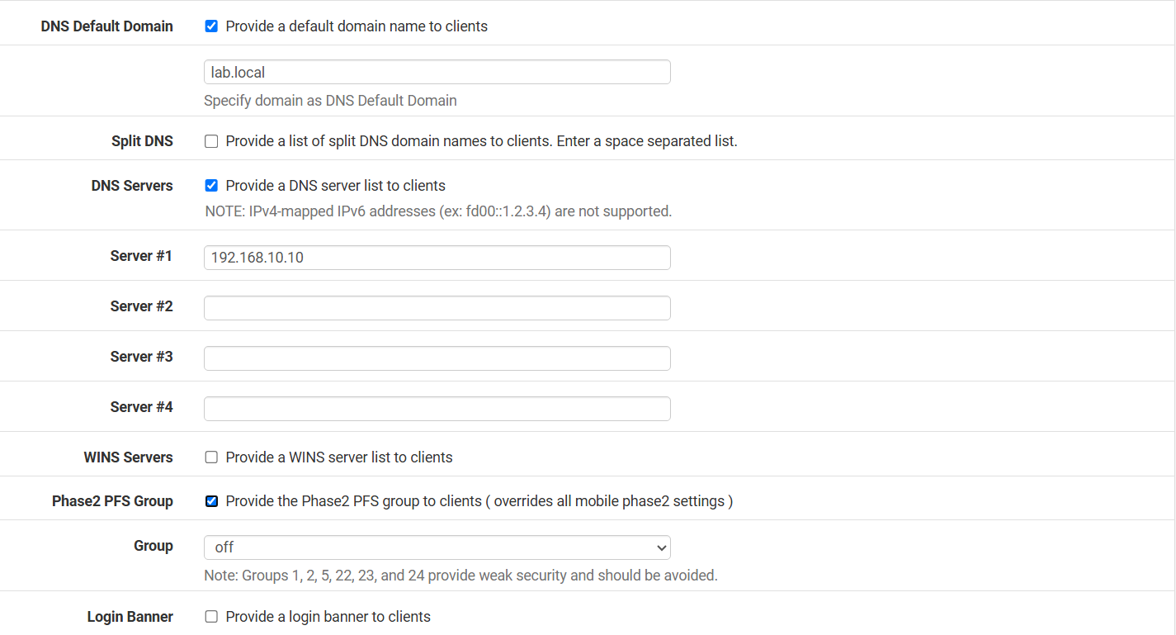

IPSec Phase 1
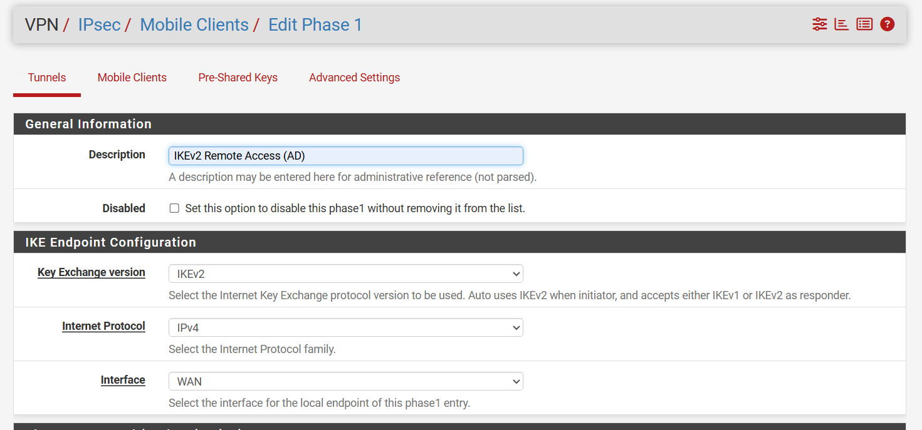
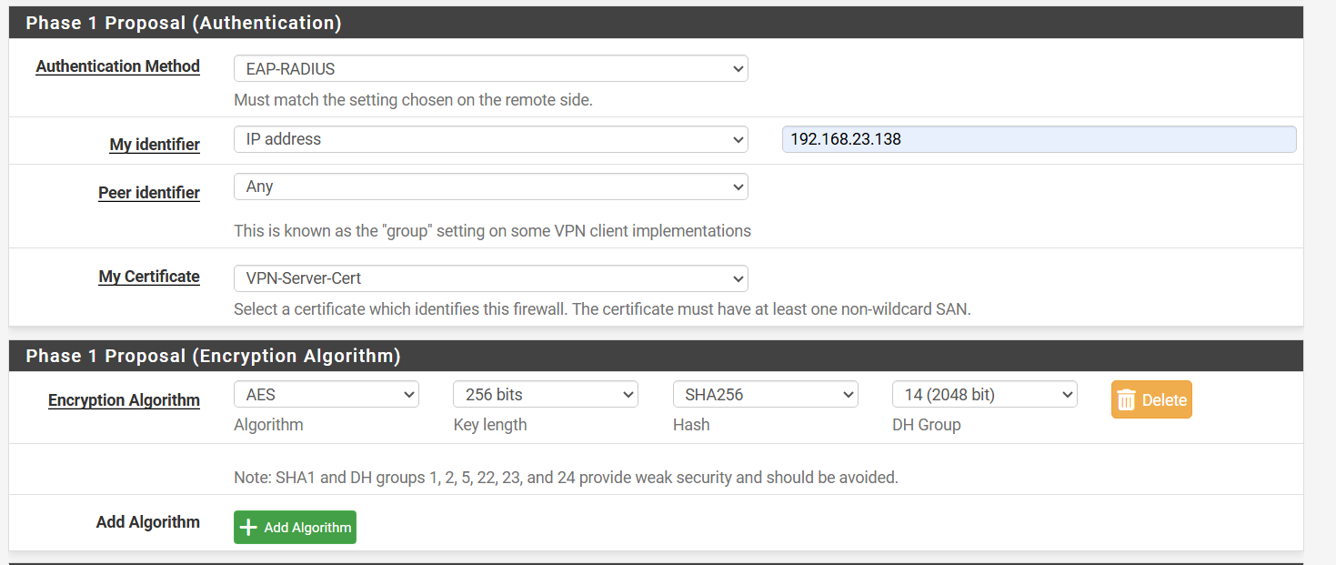

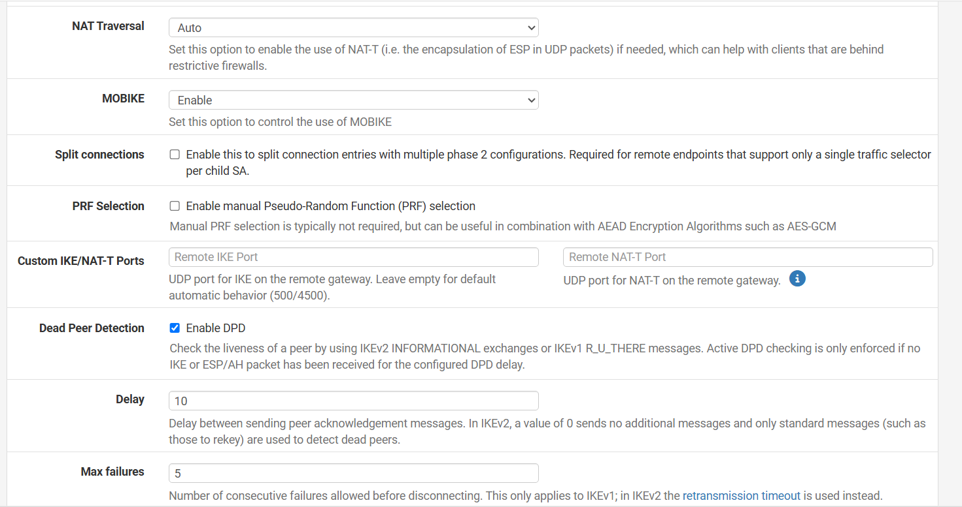

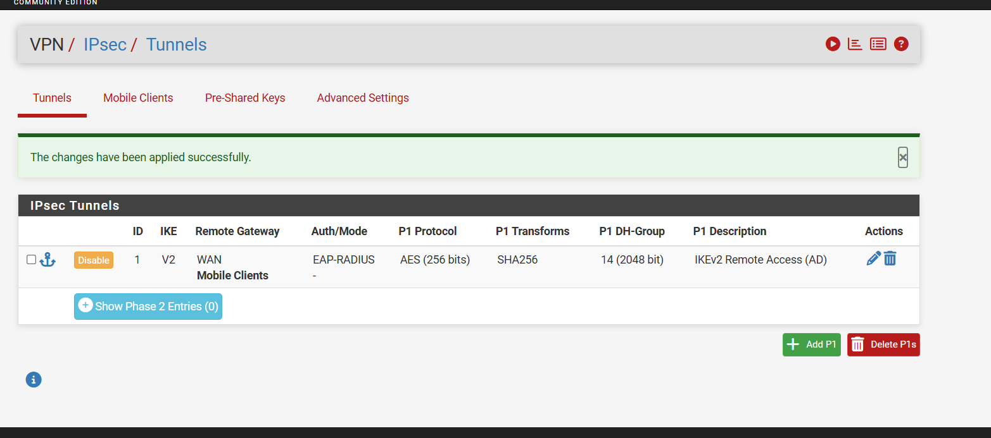

Phase 2
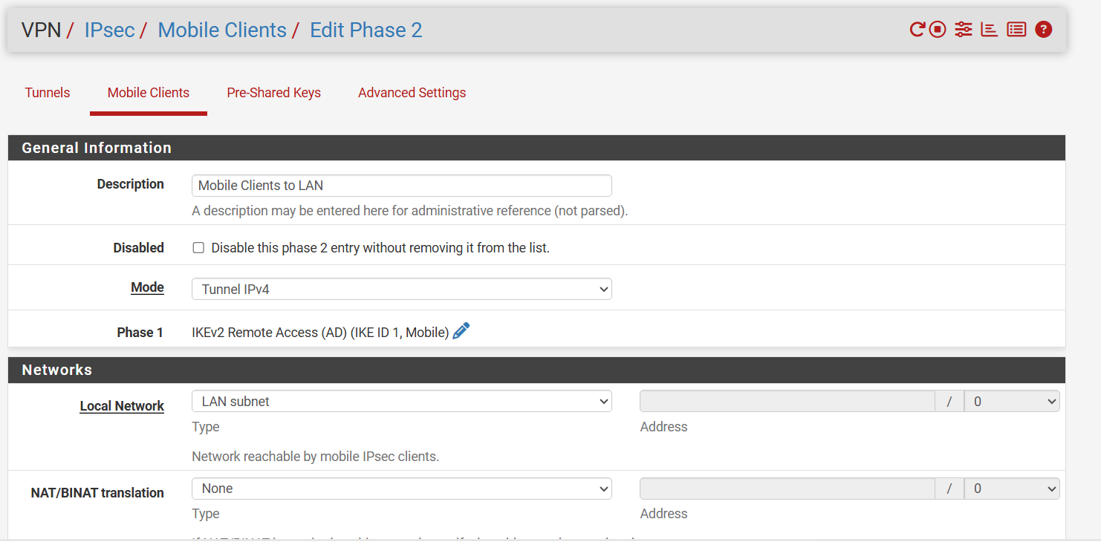

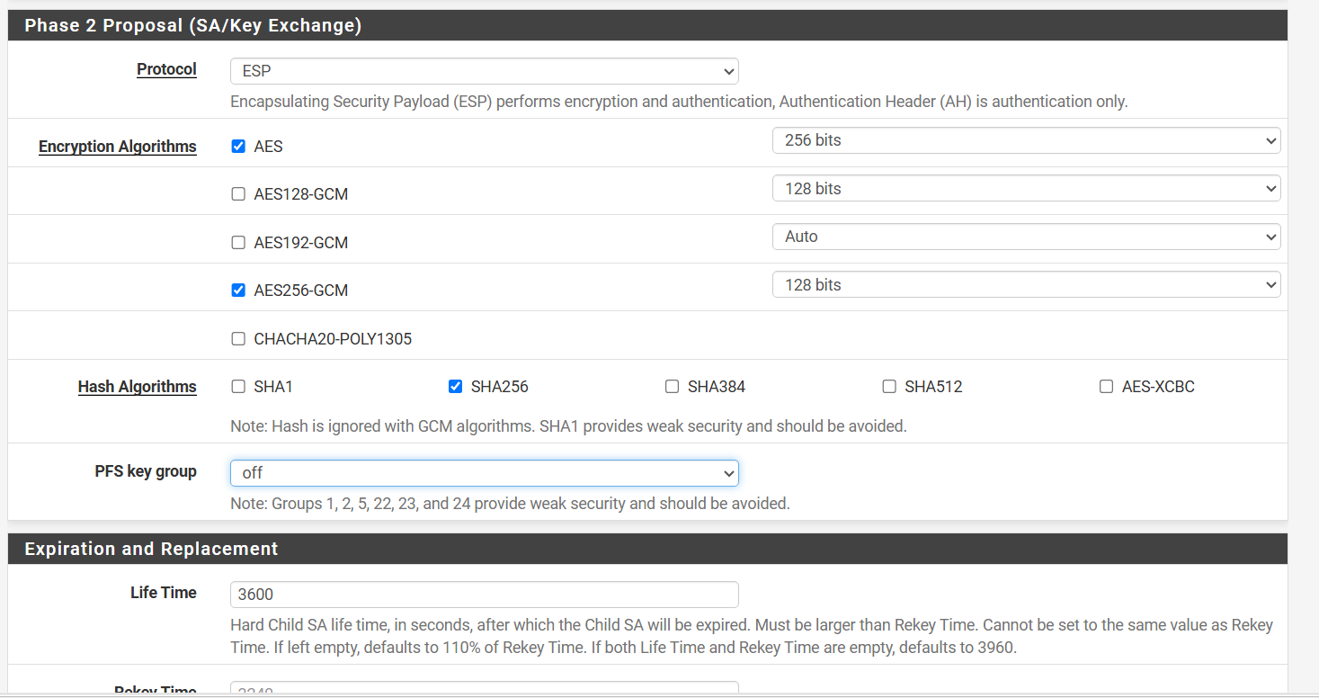

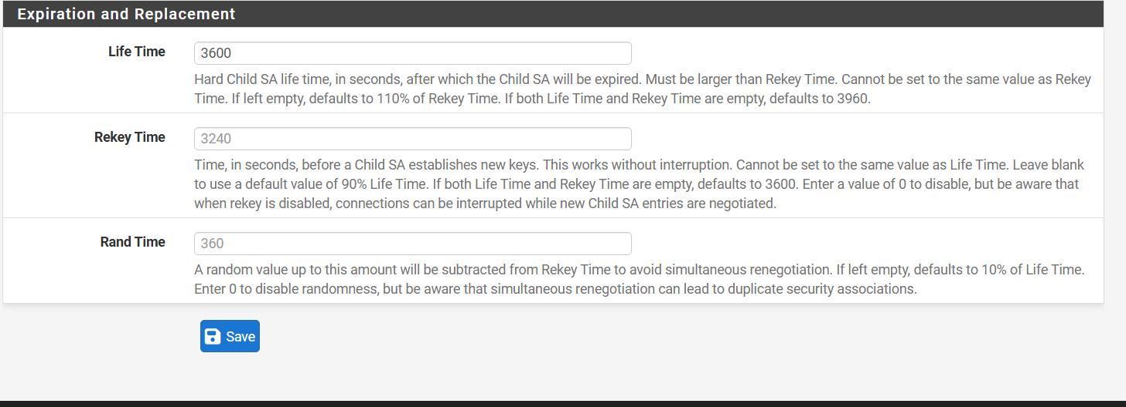

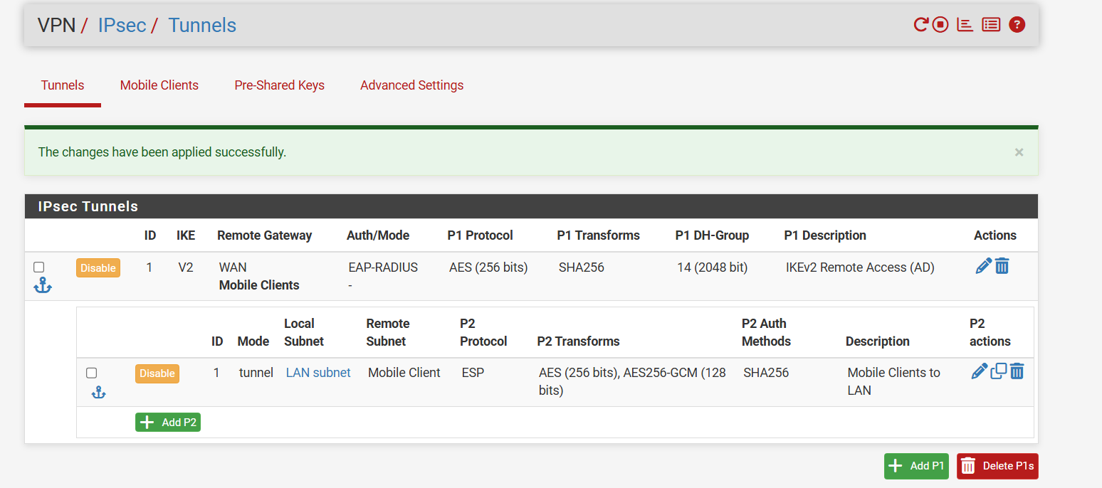

Firewall Rules for IPsec

Add WAN Firewall Rule for IPsec Handshake
Go to Firewall > Rules > WAN and click Add: • Action: Pass • Interface: WAN • Address Family: IPv4 • Protocol: UDP • Destination: WAN address • Destination Port Range: From 500 (ISAKMP) to 4500 (IPsec NAT-T) Click Save and Apply Changes. Verification: The rule appears in the list allowing UDP 500/4500 into WAN address.
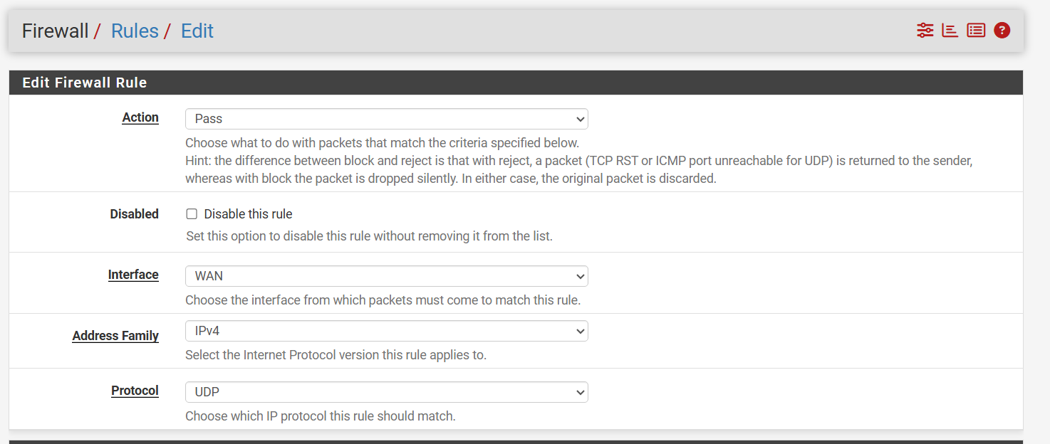
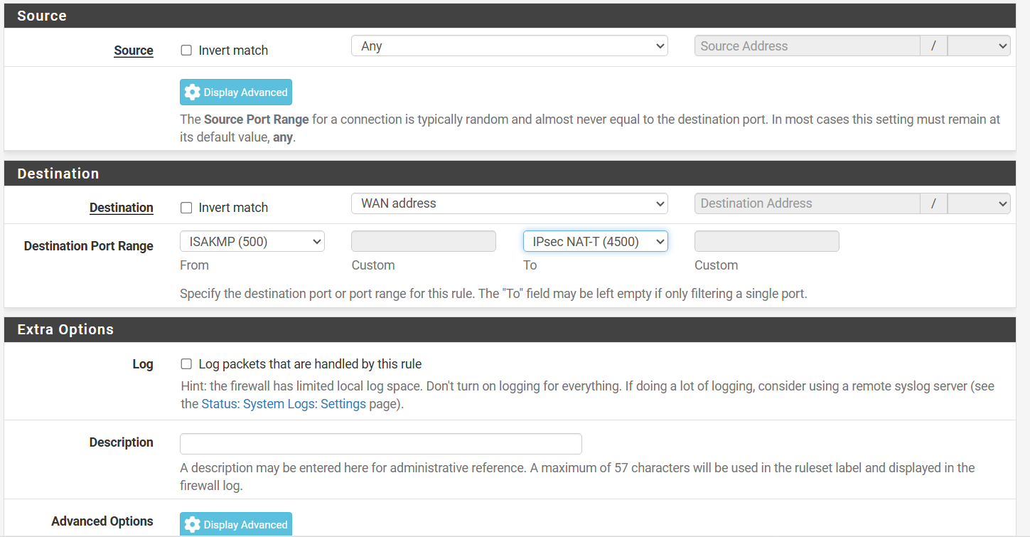

2.Add IPsec Firewall Rule for Traffic:
Go to Firewall > Rules > IPsec and click Add: • Action: Pass • Interface: IPsec • Address Family: IPv4 • Protocol: Any • Source: Network > 10.10.100.0/24 (Mobile client virtual pool) • Destination: LAN net (or Any) Click Save and Apply Changes. Verification: The IPsec tab displays an active pass rule for traffic originating from the 10.10.100.0/24 subnet.

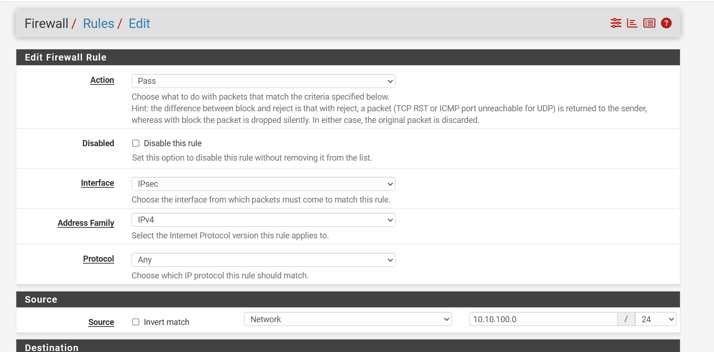

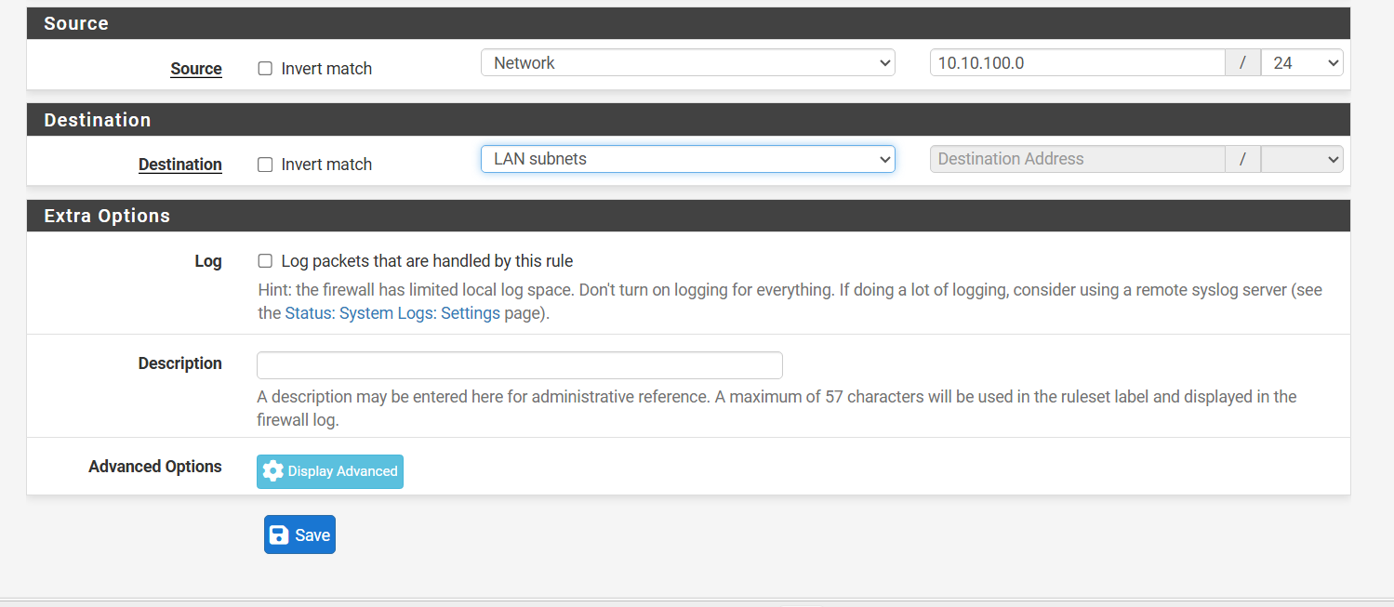

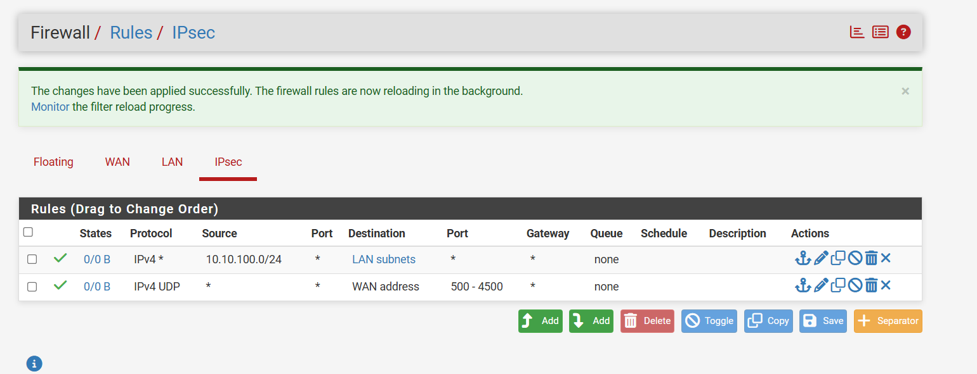

Tailscale
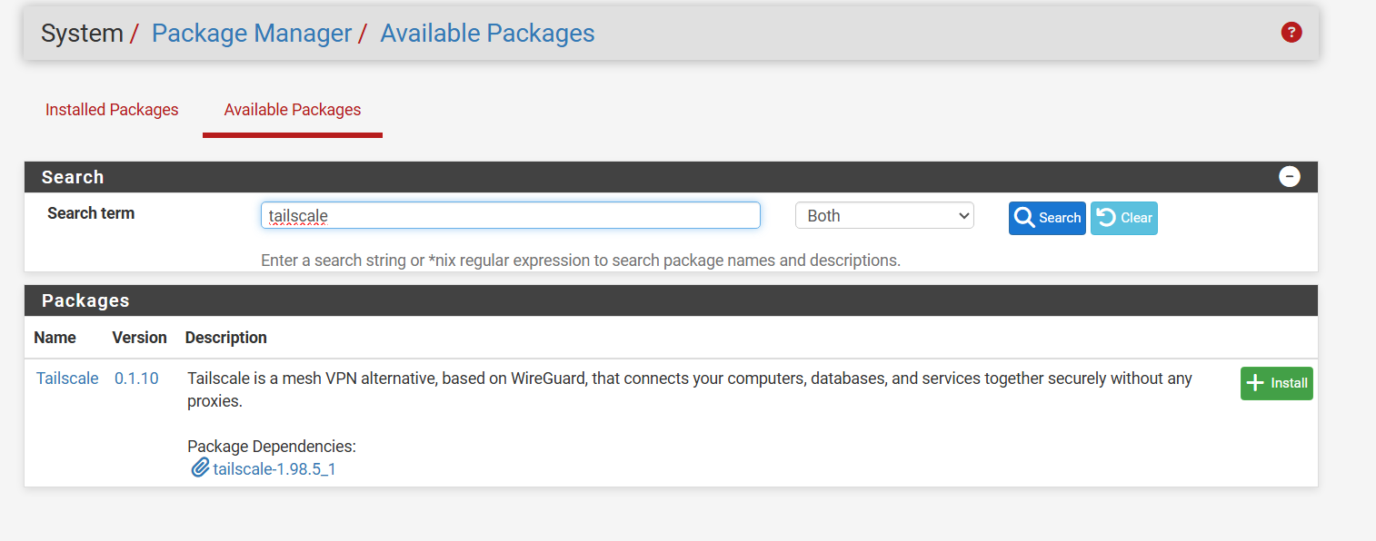
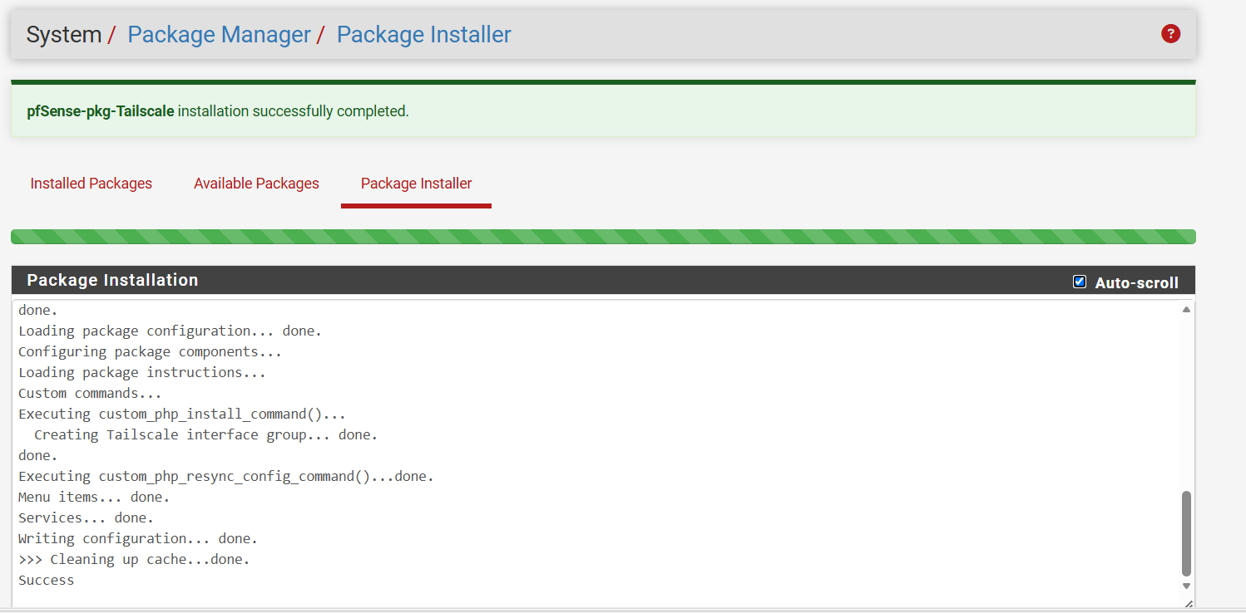
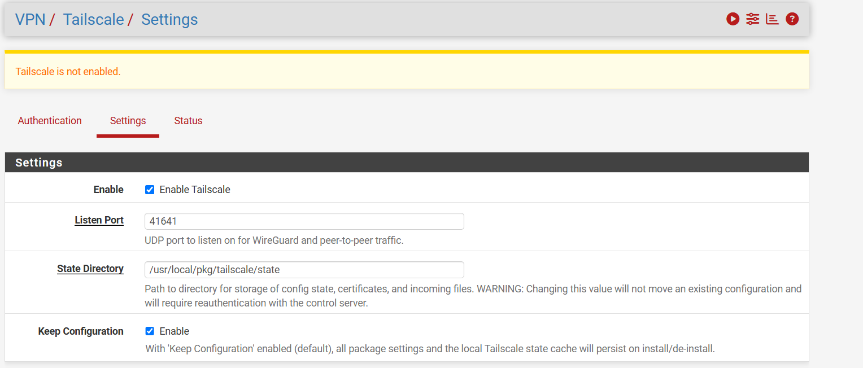

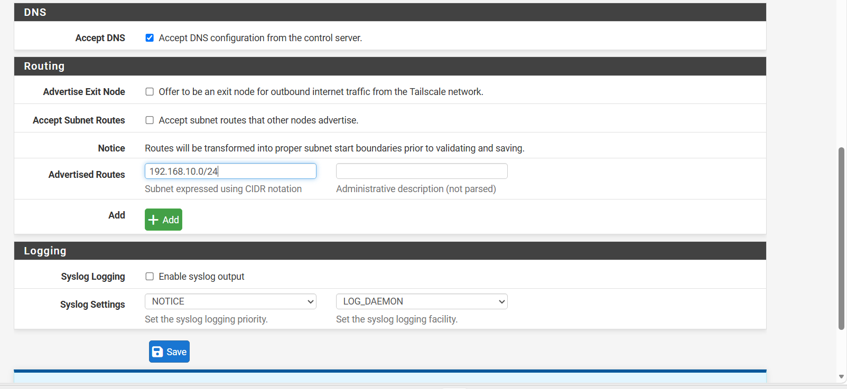
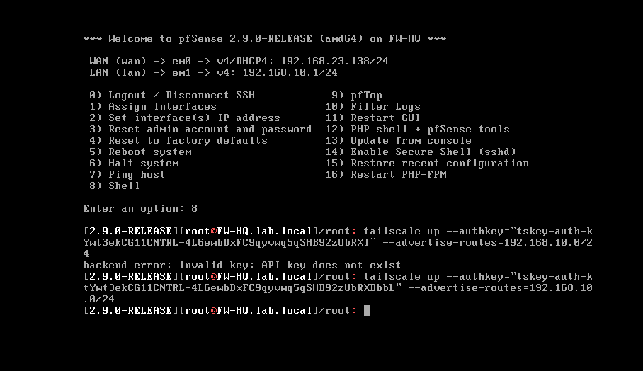

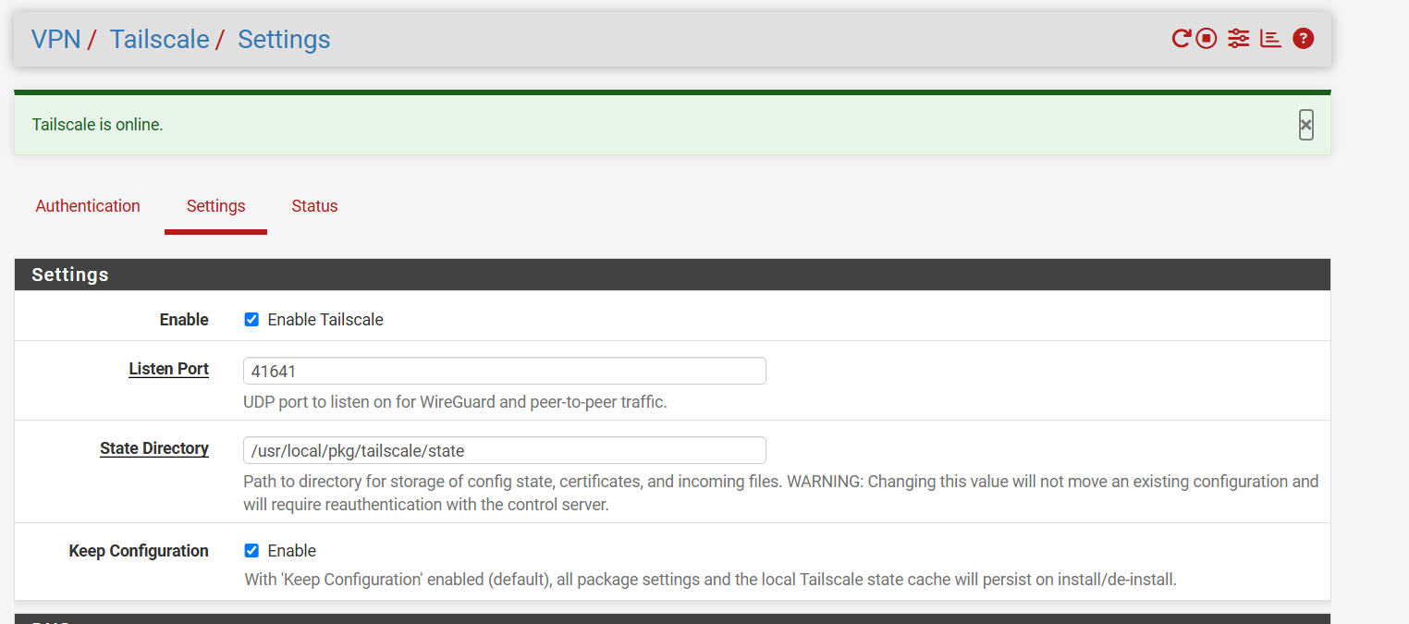

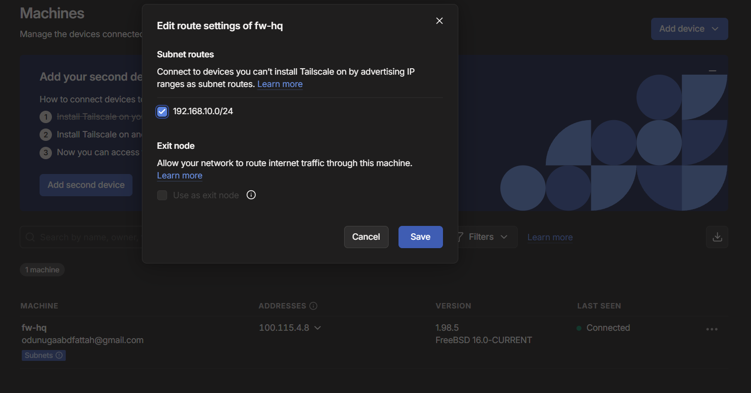

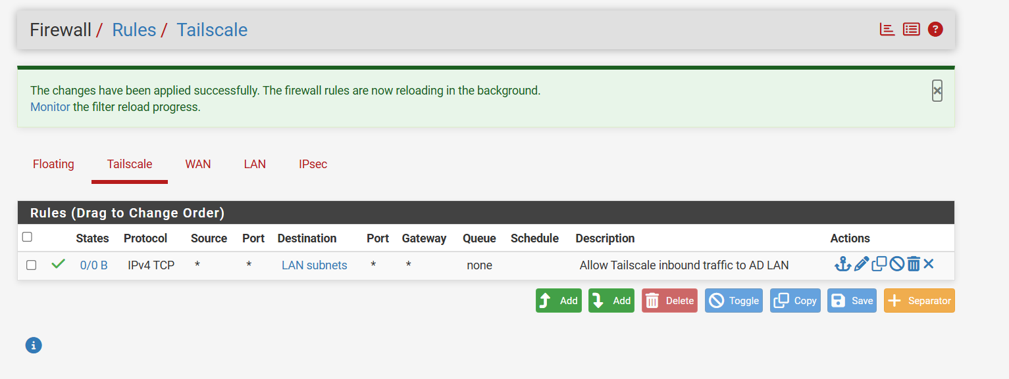

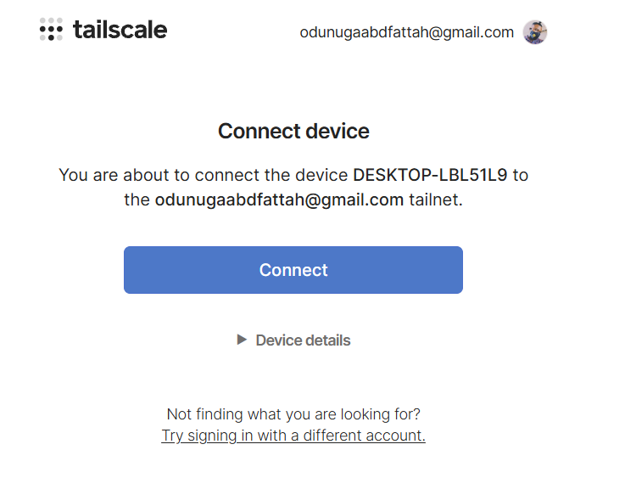

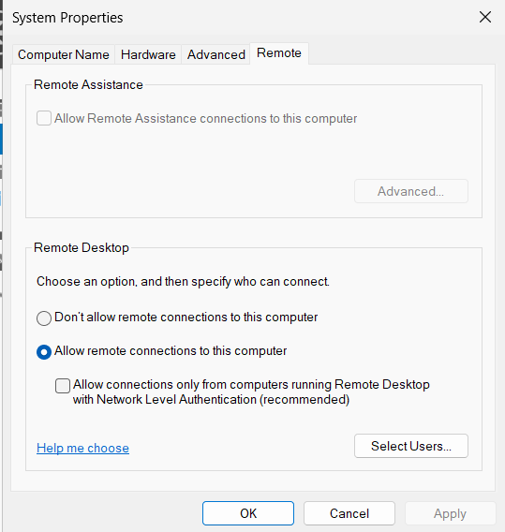
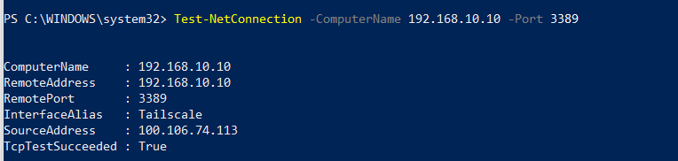
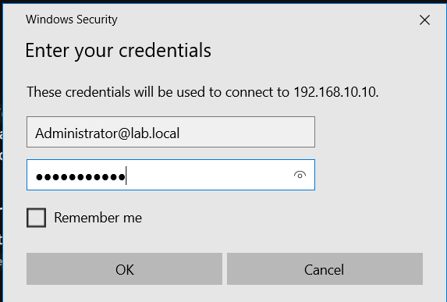
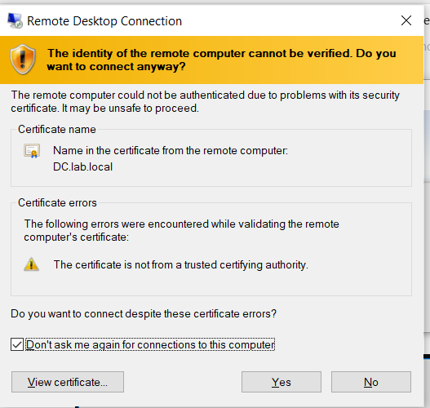

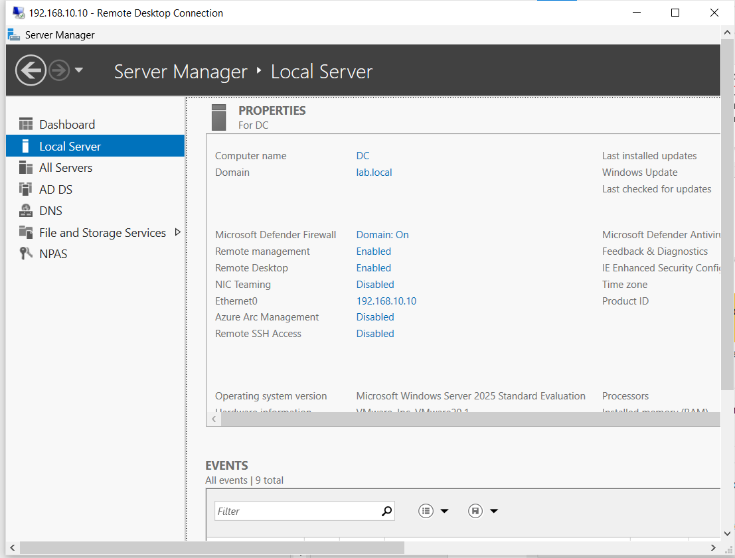

Testing on my Windows



